**Check out our Schedule of Activities inside this issue:**

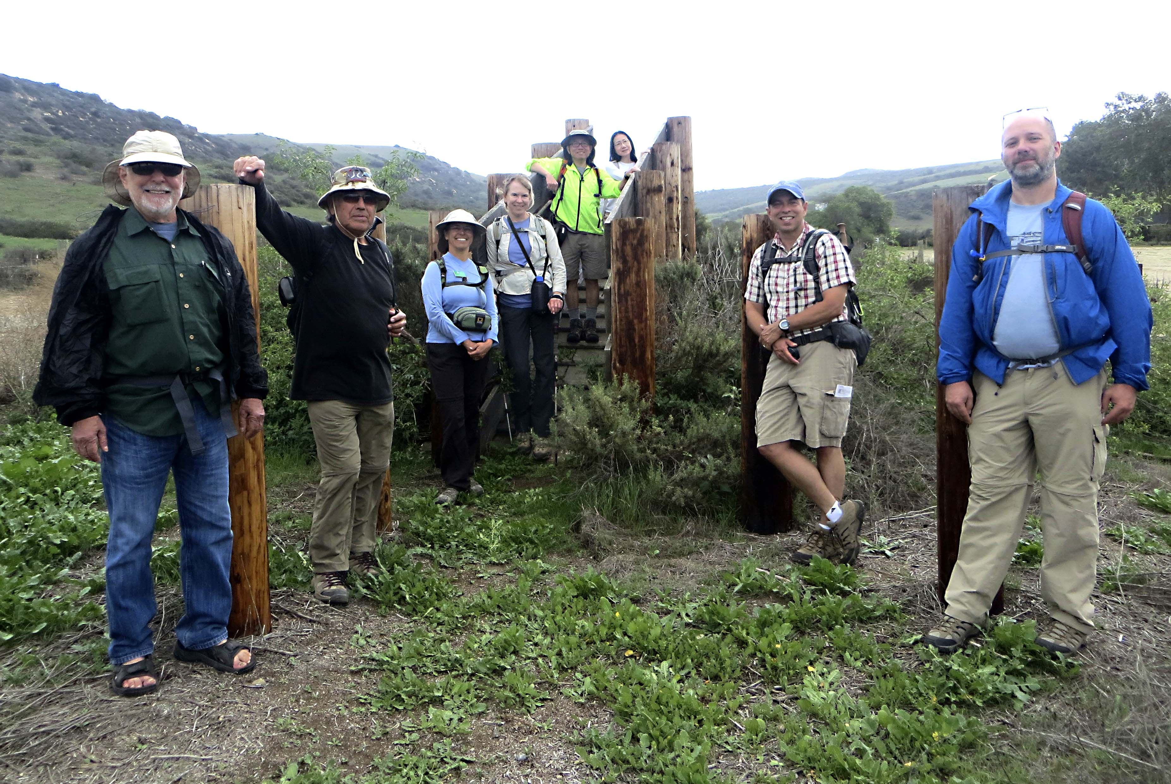

**Boomer Canyon Hike Photo by Donna Specht**

**Conditioning Hikes& Local Hikes**

**Hike for Conservation – Bolsa Chica Ecological Reserve~~,~~ Trail Maintenance**

**203040s Events, Backpacking, Social & Family Events**

**Harwood Lodge Fall Festival**

**Check our website for complete Schedule:**

**http://angeles.sierraclub.org/ocss**

SATURDAY, SEPTEMBER 30 - OCTOBER 1 OCSS

**O: Harwood Lodge Fall Festival:** Enjoy clear mountain air, hiking, music, relaxation, blue skies and beautiful mountain views and celebrate the beginning of Fall at Harwood Lodge. Musicians bring your instruments. Newcomers welcome. Includes hikes to the Waterfall and a special Geology hike with Jay Schneider. Includes Saturday and Sunday hikes, Happy Hour, lodge fees, Saturday night dinner. Sunday breakfast, hike, shared chores and check out by 3pm. http://angeles.sierraclub.org/harwood\_lodge Send 1 self addressed stamped envelope OR e mail address, phones, address, carpool info, $60 with Sierra Club# or $75 non-member (check payable OCSS to Reservationist/ Co Leader: Donna Specht, 22221 Wood Island Lane, Huntington Beach, CA 92646. Leaders: Richard Booth, Jay Schneider

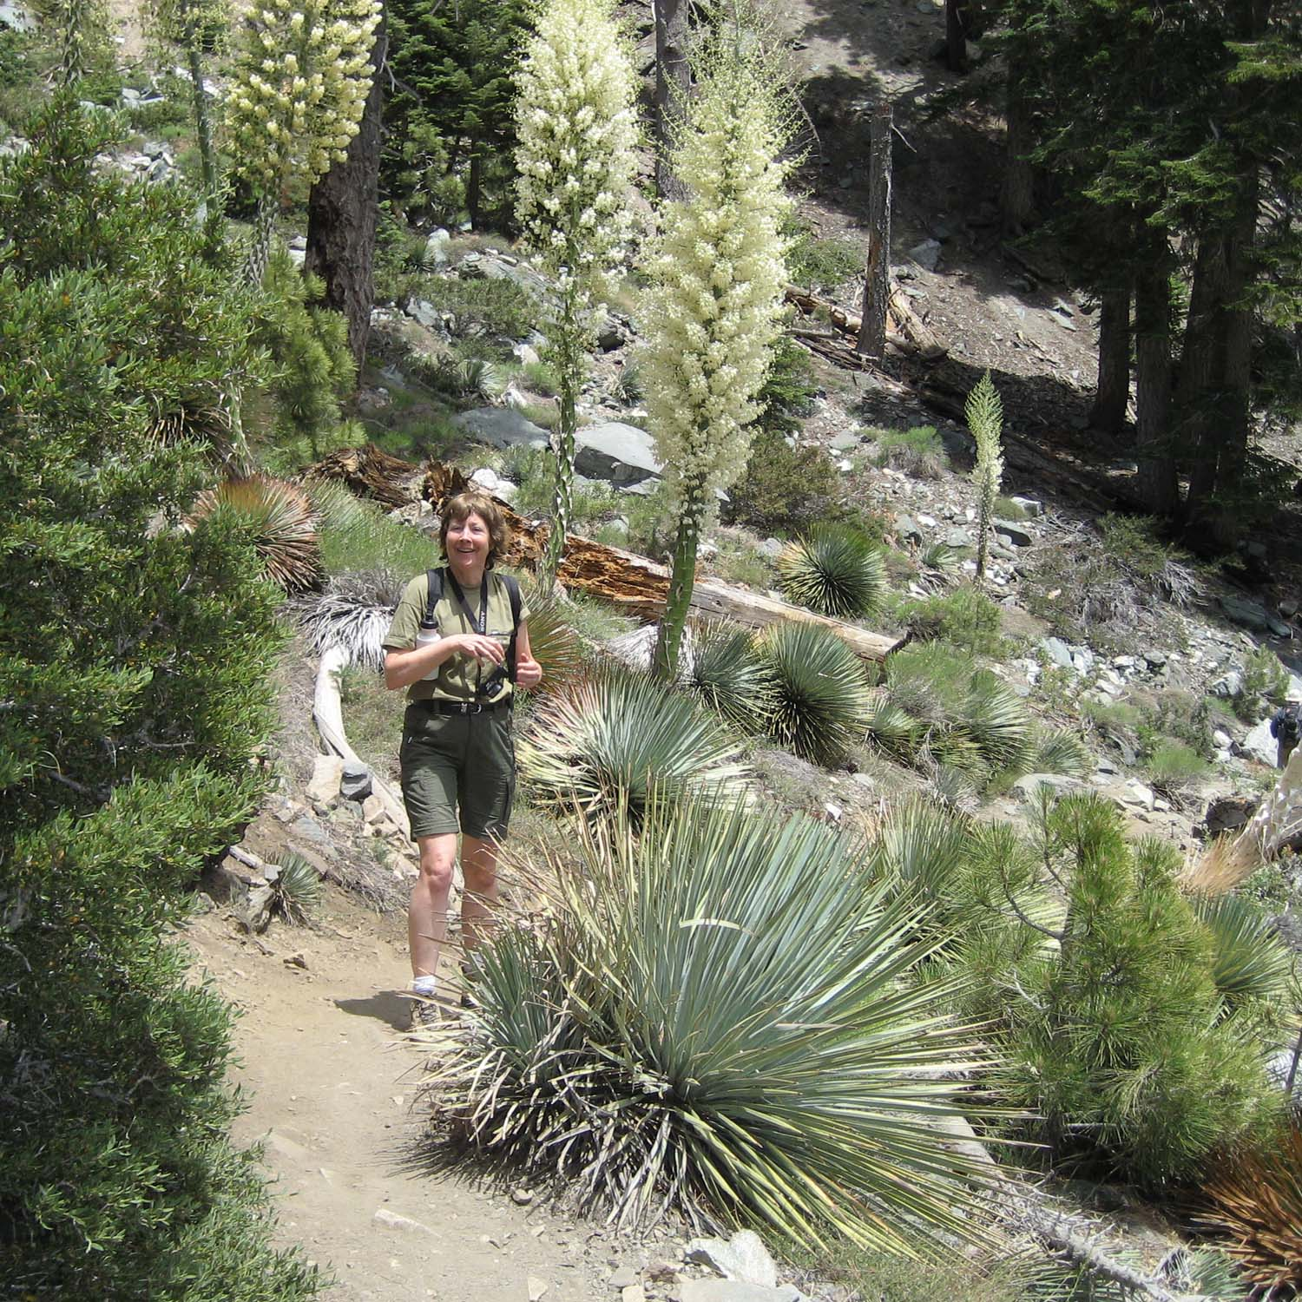

**Photo by Donna Specht**

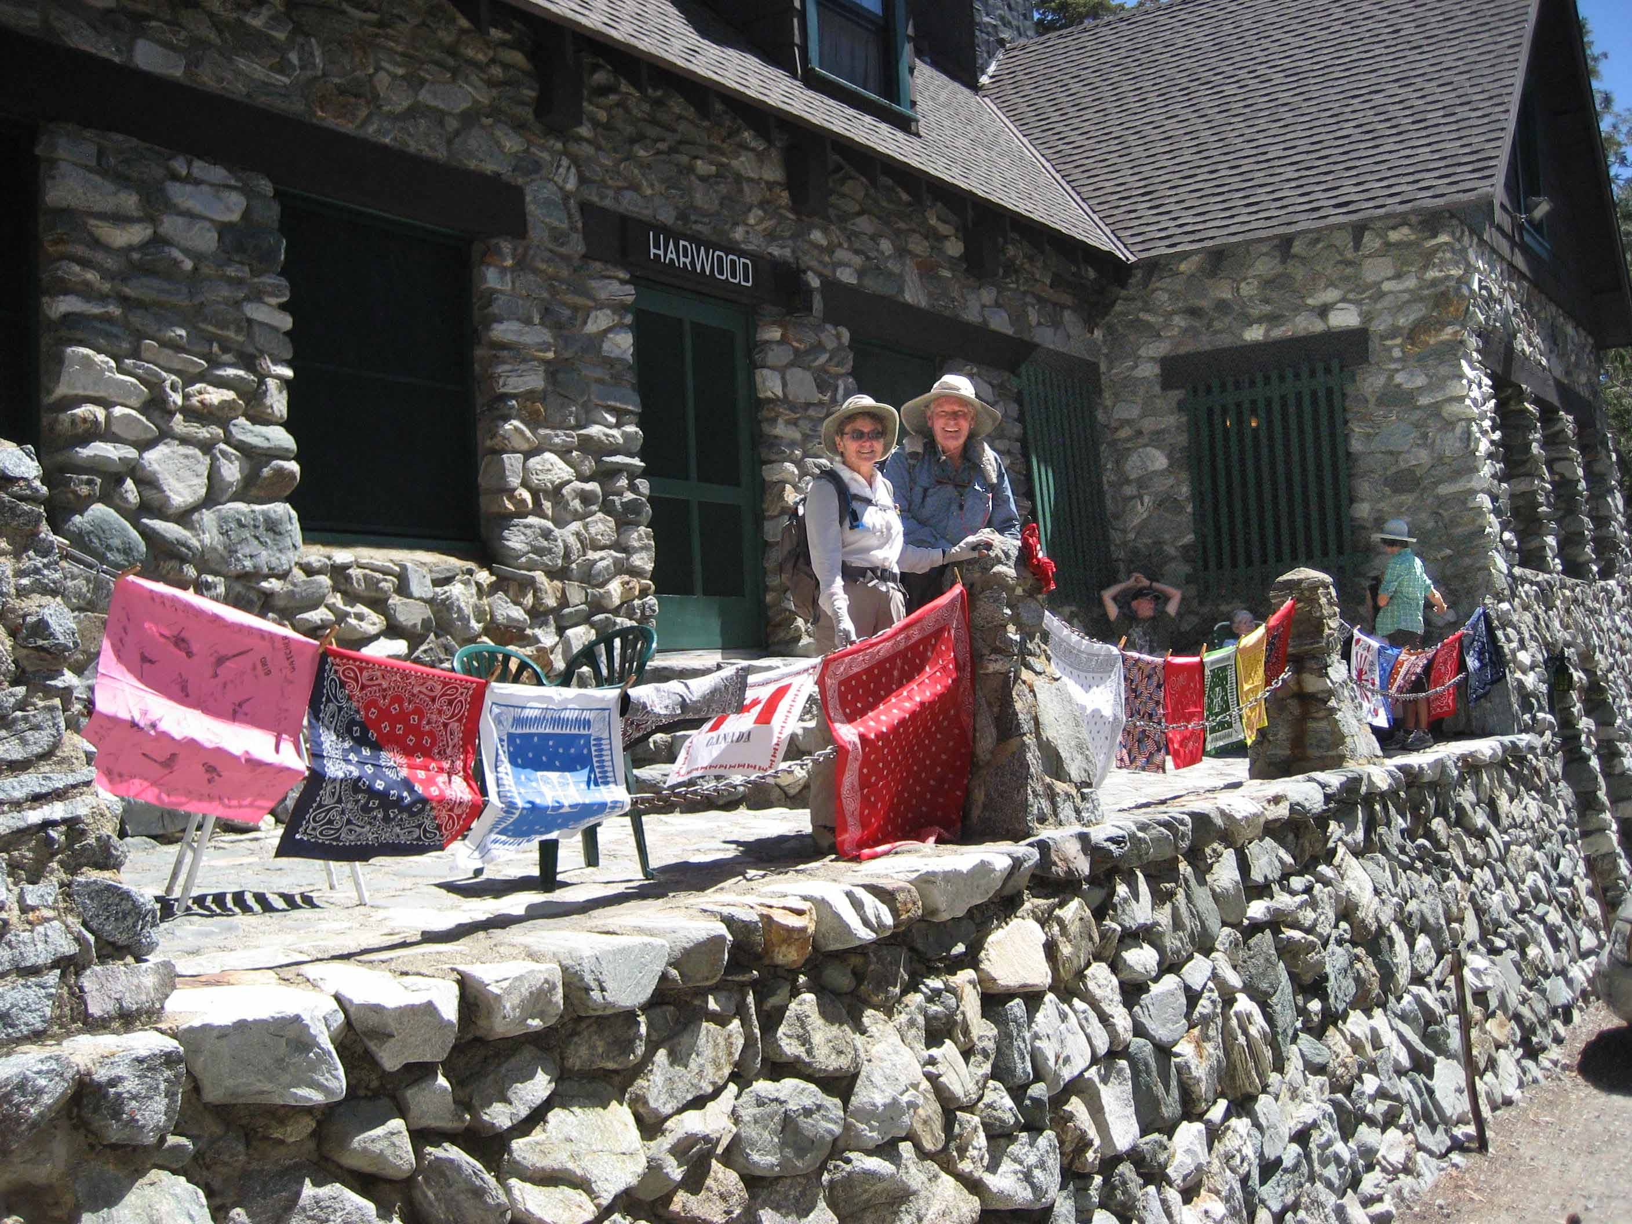

**Harwood Lodge Photo by Donna Specht**

**Angeles Chapter Annual Awards Banquet May 7, 2017 at the Brookside Country Club in Pasadena honors two Orange County Sierrans with Outings Service Awards:**

**Brooks Chadwick** is a 40 year Life member of the Sierra Club. Joining OCSS In 1986 with his wife Dorie, he is one of the original members of the OCSS Ski Committee. During the 1980’s and ‘90’s he led or assisted on cross country ski trips to June Lake, Mammoth Lakes, Colorado and New Mexico. During the 2000’s, Brooks continued to lead and assist on ski trips to Mammoth and the Presidents Holiday Yosemite in Winter ski trips. Brooks is also a pilot and did some advance scouting of ski trips by flying into local airports. Flying with Brooks in his 4-seater prop plane meant (due to weight limitations) boarding with only your skis, boots, poles, day pack and the clothes you were wearing. It also meant pulling out your Thermarest and sleeping under the wings on the tarmac until daylight. Or flying over the High Sierra and landing at the Mammoth Lakes airport in a cross wind. Brooks is well known for his wild red plaid ski pants and Peruvian knit hat. Brooks is a valued conditioning hike leader for the Palos Verdes South Bay Regional Group and is still a member of OCSS.

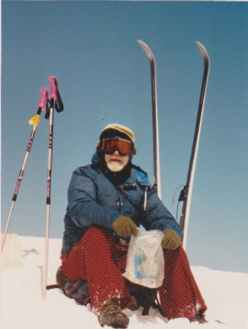

**Dave Black** For more than 20 years Dave has led or participated in Sierra Club trips from day hikes to multi-day mountain and desert backpack outings, including winter snow shoe and snow camping adventures. Dave was an associate instructor with the OCSS Beginning Backpacking Class for five years and presented snowshoe demonstrations for the Snowsports Classes. His demo ending with “in 15 minutes you are an expert snowshoer” was always a classic. Dave has assisted as a backcountry ski leader and continues as a snowshoe leader for the OCSS Mammoth in Winter bus trips. He has been a Sierra Club member since 1994 and an “I” rated leader since 1995 and has recently completed twenty years as a student and instructor with the Orange County Section of the Wilderness Travel Course (WTC). Outside the Sierra Club, Dave’s background includes US Army military service, desert exploration, rock, ice, and navigation classes with the Austrian Alpine Club, and summits of alpine peaks and of Mt. Kilimanjaro, Grand Canyon Rim to Rim hikes, as well as portions of the Appalachian Trail. Dave also recently completed the five hundred mile Camino de Santiago pilgrimage walk in Spain.

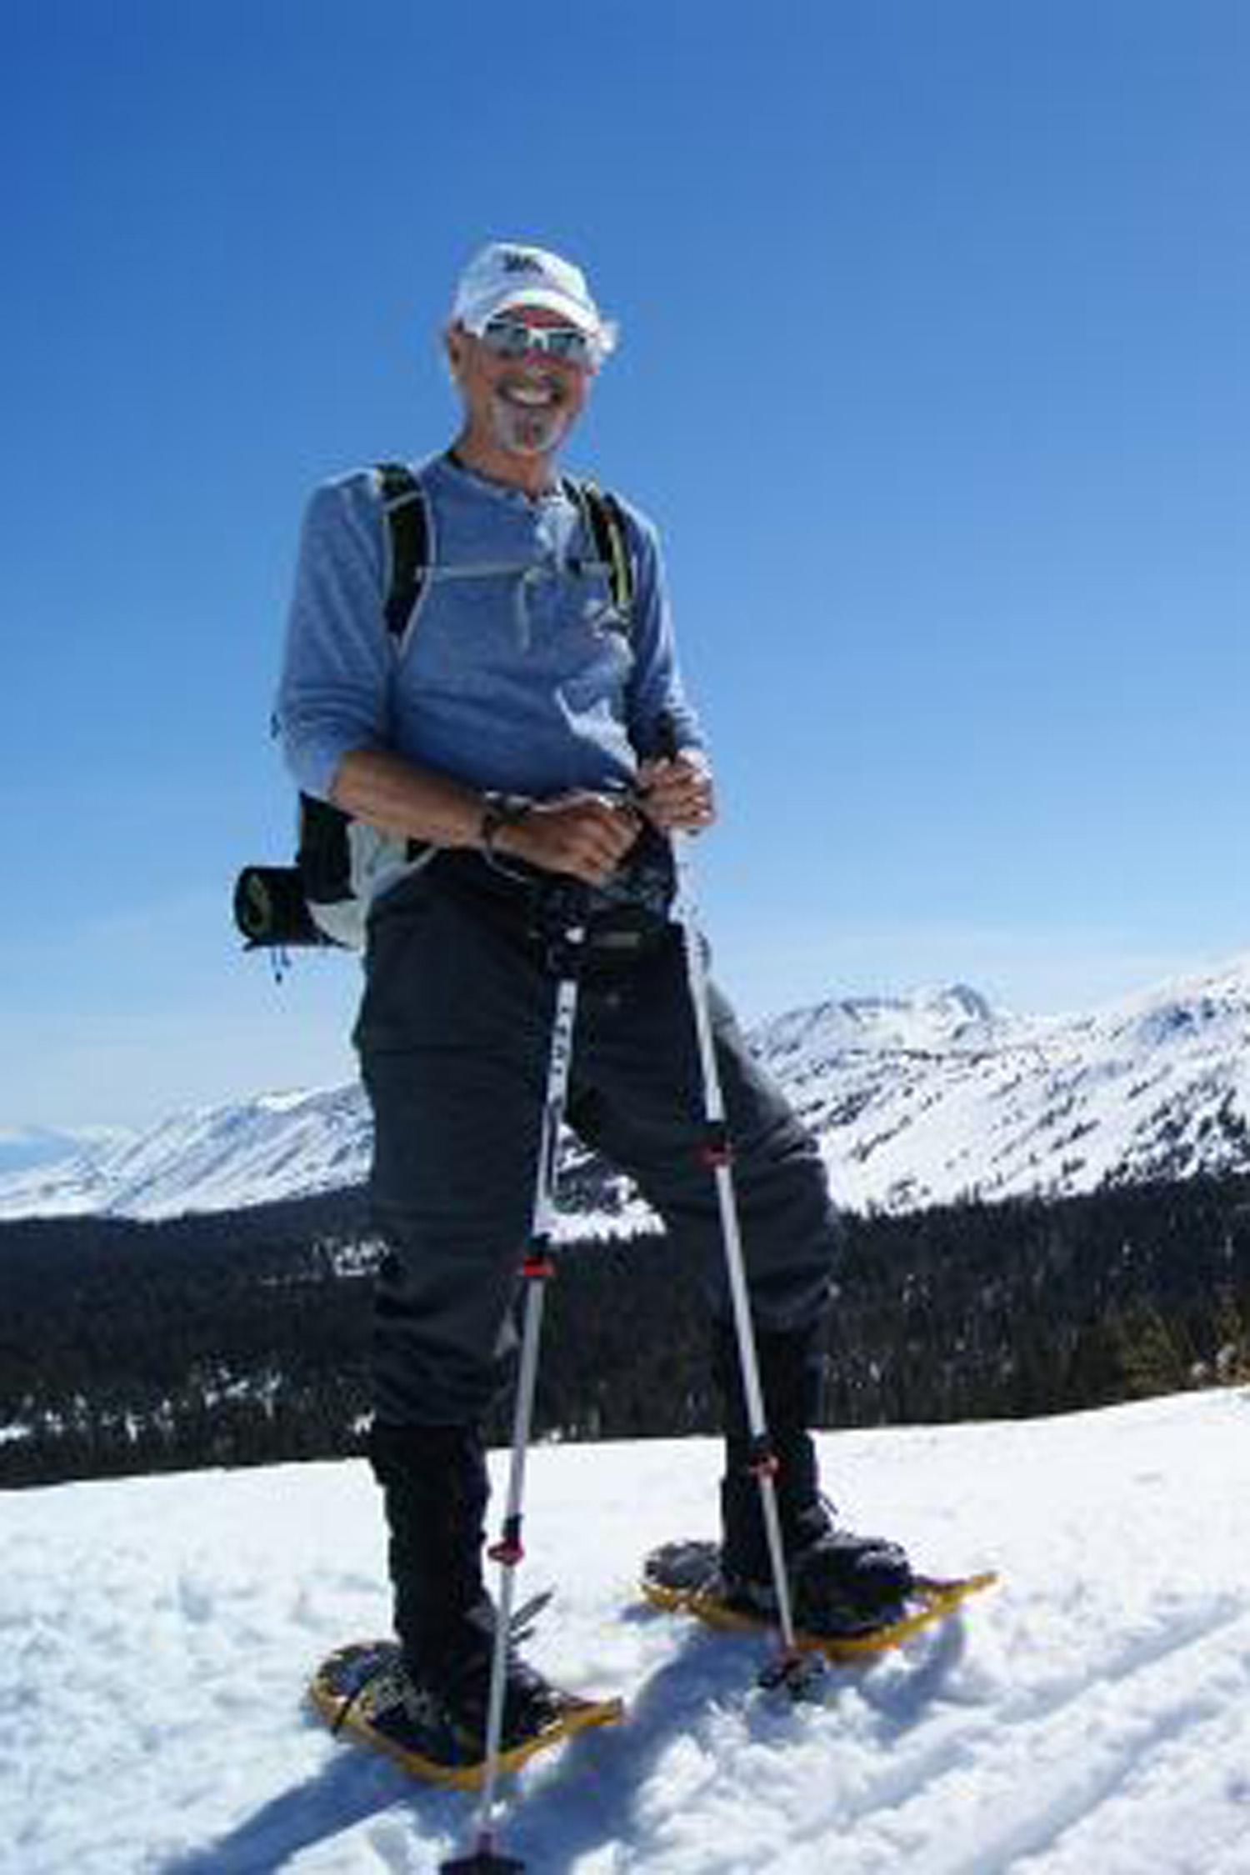

**Photo by Diana Gonzales**

WED, may 15 7-9:30 pm MGMNT COMMITTEE MTG

Open to all members. Meeting starts at 7PM. Guests must request to be on the agenda if they wish to make a presentation. Guest Agenda items must be submitted one week in advance to Donna. **Contact Donna Specht for location and directions to the meeting.**

**NO MEETING IN JUNE**

**PROGRAMS**

Saturday, June 3, 5:00 PM            OCSS

Outings Planning Squaretable BBQ: Join Orange County Sierrans, everyone welcome. Come help plan, schedule an event, find a co-leader and coordinate events for the coming months. Bring your ideas. Meet the leaders. Learn how to plan your own event or how to become a leader. Remember you don't have to be a leader to host a social event. Volunteers welcome, lots of opportunities. Bring your laptops, we can sign on the the Chapter website and navigate online scheduling and post your event. How cool is that? We will provide the BBQ hot dogs. Bring a side dish and your favorite drink. RSVP to Donna Specht Specht 714-963-6345 (donnaspecht@juno.com) Location and directions provided. Leaders: Houria Hall, Karen Belville, Annie Simjee, Joel Kenyon

OCSS HAS TWO PROVISIONAL OUTINGS COMING UP.  PLEASE COME ON OUT AND SUPPORT OUR NEW PROVISIONAL LEADERS.  WE LOOK FORWARD TO THEIR LEADERSHIP!

Saturday, May 27, 9:00 AM OCSS

**O: Bommer Canyon, Irvine:** Easy pace, 4.8 mile loop, 250 feet gain, approximately 3 hours. The Bommer Canyon Trail is well maintained by the Irvine Conservancy with beautiful wild land views. Newcomers Welcome. Meet in the parking lot near the tennis courts, Turtle Rock Community Park, 1 Sunnyhill, Irvine CA. Bring Water, snacks or lunch, sun protection, hat, light hiking boots, camera. Rain cancel. Optional, after the hike, visit Turtle Rock Nature Center and have lunch in the park. Provisional Leader:  Cherry Postic 714-990-9250 [cherwiski@hotmail.com](http://webmailb.juno.com/webmail/new/5?session_redirect=true&userinfo=2b221bf4227dfb54e883a0a456272adb&count=1492123083&randid=167622668), Donna Specht

**O2: San Jacinto Backpack to Round Valley:** Come and experience the wilderness of San Jacinto State Park via the Palm Springs Tramway (8420’). Enjoy the pine forests as we hike to Round Valley (2.1 miles), set up camp, and continue to Wellman Divide (9720’) and up Deer Springs Trail to San Jacinto Peak (10,834’) for 3.7 additional miles. This is a moderately strenuous hike with 2434’ gain. We will return to camp and enjoy happy hour Saturday night. On Sunday morning, we will hike back to the tramway. Bring money for tramway fee, backpack, tent, sleeping bag, pad, cooking gear, at least 4 liters of water, warm layered clothing, hiking boots, poles, 10 essentials, bear canister, and something to share for happy hour. Group size limited due to permit. Send recent conditioning and backpack experience to Provisional Leader Karen Belville, (karen.belville@gmail.com) Asst Leader: Fran Penn

TUE & THU 6:30-8:00 PM IRVINE CONDITIONING HIKES

**O: Easy/Moderate/Tiger paced hikes,** 4-7 mi rt on hilly trails. Bring water, light hiking boots. 405 Fwy, exit S at University/Jeffrey, L on Ridgeline, L on Turtle Rock, pass Sunnyhill, L into parking lot of Turtle Rock Community Park. Ldrs: John La Rue, Joel Kenyon, Fran Penn, Jim Palmer, Donna Specht, Maura Van Strien, Karim Khoshab, Norman Montgomery, Shaune Hand, Michael Mavrovouniotis, and Mike Winfield.

TUE 6:30 PM               FULLERTON CONDITIONING HIKE, OCSS, RIO HONDO

**O: Fullerton Conditioning Hike**: Hike with our social group on this regular weekly easy conditioning hike of 4-5 miles in the gentle hills of Fullerton. Slow to medium pace is great for beginners. Each week we rotate through numerous trails in the area to provide new experiences. Last Tuesday of each month, we have a potluck dinner. **Hike scheduled during daylight savings time, i.e. March through October.** Meet at the east end of Laguna Lake in Fullerton (from Harbor Blvd, W on Hermosa Dr, L on Lakeside Dr for ½ block and park on the street). Look for hikers on east side of Lakeside Dr. Wear sturdy boots, bring water, flashlight. Leaders: Martin Kluck, Joel Ortmann, Margee Hills, Houria Hall, Alan Daniels, Ed Khatch. Host: Sanford Opperman

**SAT 8:00AM PETERS CANYON CONDITIONING HIKES,**

**Peter’s Canyon Conditioning** This hike started in 1993 when some of our leaders went over to check it out. The hike has been really popular and has been led continuously since that time. After more than 20 years of OCSS sponsoring this weekly conditioning hike, the leaders are calling it done. The hike will be reorganized as special events on a specific dates. Many thanks to Sharry Puraty, Shilo Bartlett, Bart Bartlett, Jan Nemmert, Fran Penn and Norman Montgomery for many years of service. They are all still qualified and active leaders, so watch this space for special events.



**Sharry Puraty**

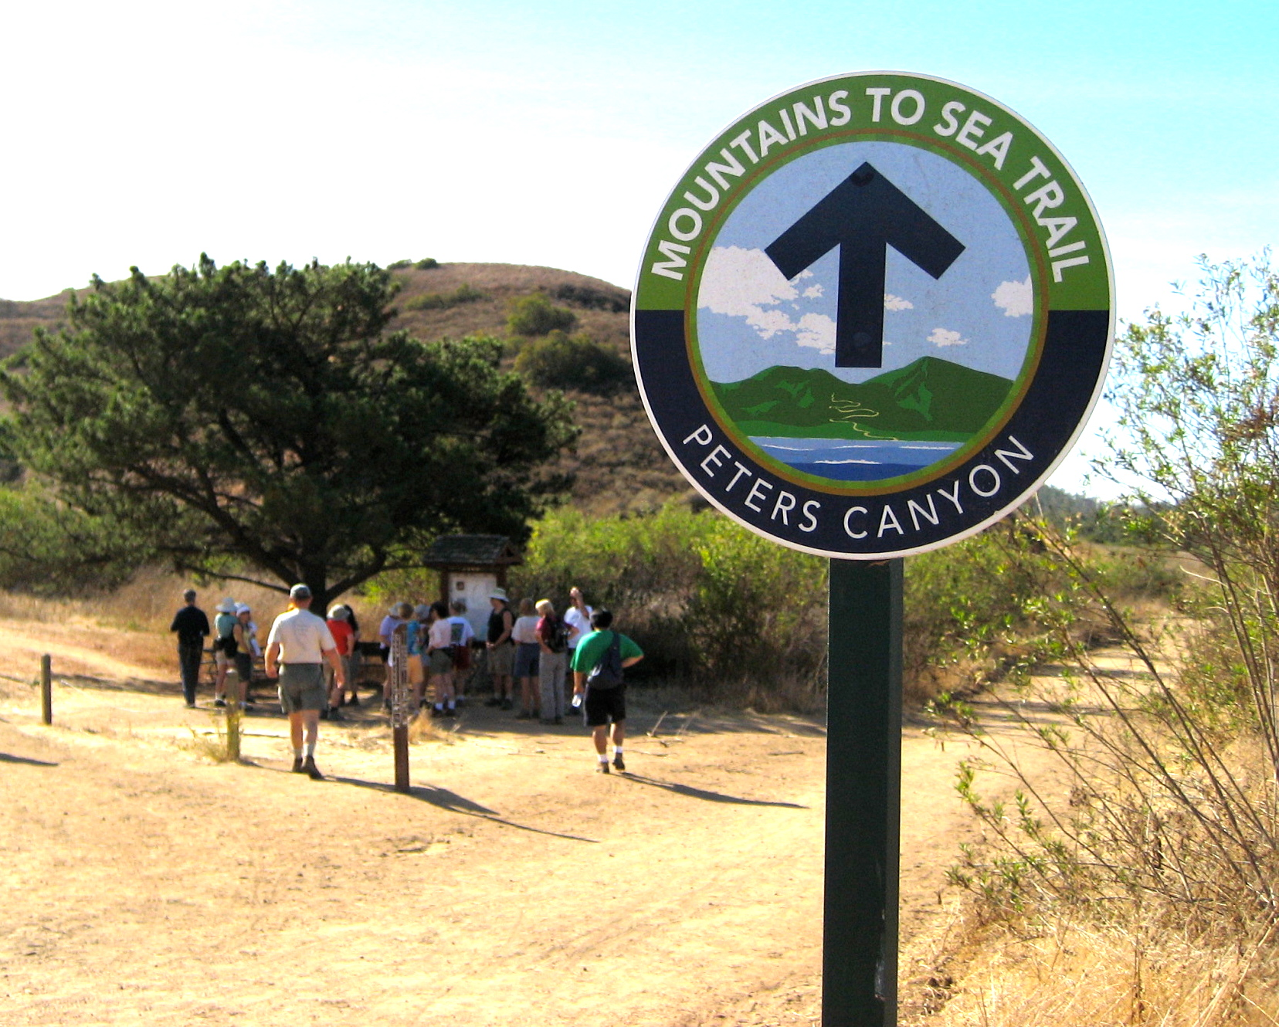

**Peters Canyon**

**Before you go, be prepared: Some General Information**

**Liability Waivers**

In order to participate in a Sierra Club outing, you must sign a liability waiver. If you would like to read a copy of the waiver before attending the outing, please see http://www.sierraclub.org/outings/chapter/forms/

**California Seller of Travel**

CST #2087766-40. Registration as a seller of travel does not constitute approval by the State of California.

**Trip Reservation And Refund Policy**

When two costs are shown for a trip, the lower cost is for Sierra Club members who must include their SC membership number (SC#) with the reservation. Make checks payable to Orange County Sierrans Section (OCSS) unless otherwise indicated. On OCSS events, if cancellation is received 35 days prior to event (some exceptions), there is no charge. Thereafter, refunds (less 10%) will be made if trip is full and space is resold to suitable replacement. Some trips have unique cancellation policies, please refer to trip write-up. Other groups may have a different policy.

**Rideshare Meeting Points:**

**Orange County, North:** Park-N-Ride, E side of Tustin Ave just S of Lincoln Av, Orange off SR55.

**Orange County, South:** Ortega Business Center parking lot, 1/4 mi E of 5 Fwy on SE corner of Ortega Hwy and Rancho Viejo in San Juan Capistrano.

Go to the chapter website for additional rideshare points:

http://angeles2.sierraclub.org/get\_outdoors/know\_you\_go/rideshare\_meeting\_places

In the interest of facilitating the logistics of some outings, it is customary that participants make voluntary carpooling arrangements. The Sierra Club does not have insurance for carpooling arrangements and assumes no liability for them. Carpooling, ride sharing or anything similar is strictly a private arrangement among participants. Participants assume the risks of this travel. Please share the cost of gas.

**Get Involved, Get Outdoors:**

**The Angeles Chapter Schedule of Activities Now Online**

**Whether you're looking for an outdoor adventure, an opportunity to meet people, a chance to influence elected officials or just something to do on a Saturday afternoon, the Online Schedule of Activities is your guide to hundreds of events sponsored by Regional Groups, Activity Sections, Committees and Conservation Task Forces throughout** **the Angeles Chapter. Check it out at:**

**https://angeles2.sierraclub.org/activities**

**For events in South Orange County check out the website for**

**Sierra Sage Group http://sierrasage.org**

Wednesday, May 3, 9:00 AM OCG, OCSS

**O: Arroyo Trabuco:** 5 mi, 700’gain/loss. We’ll descend into the lush riparian greenery of the arroyo, then follow singlet tracks and dirt roads gently down-canyon before returning to our starting point. There are a few stream crossings. Though the water will be very shallow, hiking sticks are recommended. Meet 9:00 am at Beebe Park, 34190 Olympiad Rd, Mission Viejo. From I-5, take Alicia Pkwy east, turn R on Jeronimo (2nd major cross street) and follow it to the end: then R on Olympiad and almost immediately L at Beebe Park. Parking lot is free. Bring water, snack, light hiking shoes. Rain cancels. Ldrs: Ed Maurer, Sylvia Stevenson.

Saturday, May 6, 6:00 PM OCSS

**Upper Newport Bay Ecological Reserve Picnic:** Enjoy a lovely evening of friendship, fun, sunset and Potluck dinner at the Back Bay. Bring your favorite chair and table if needed. Take Jamboree towards ocean. Make a right on San Joaquin Hills Road. Make another right along the one way Back Bay Drive. The parking lot will be on your left. Plenty of parking. Hosts: Pamela Barton Erdahl and Chuck Erdahl, 949-786-3828,barton2erdahl@gmail.com

Thursday, May 11, 5:30 PM RIO HONDO

**O: Fullerton East Coyote Hills Hike:** Join us for a cool evening 3-4 mile hike in the gentle East Coyote Hills in Fullerton. We alternate a couple routes. One is the Panorama Trail through Panorama Nature Preserve with great views of San Gabriel Mtns. Once we reach Brea Blvd, we follow the East Coyote Hills Trail back to Vista Park. Or we cross State College and hike at Craig Park, making a loop up to Brea Dam and enjoy the lake, ducks, egrets, squirrels, and more. Slow to medium pace is great for beginners. Meet at the lower Vista Park / Summit House parking lot (entrance on west side of State College Blvd. just south of intersection with Bastanchury Rd. in Fullerton). Wear sturdy shoes; bring water, flashlight. Rain cancels. Leaders: Alan Daniels, Sandy Viernes, Margee K Hills 714-356-4031 [margeehills@gmail.com](mailto:margeehills@gmail.com), Houria Hall

Thursday, May 11, 7:30 PM RIO HONDO

**Rio Hondo Group monthly meeting** - Executive committee meeting, all are invited. Join us for dinner or a snack at 7:00 PM followed by the meeting at 7:30. WHERE: Coco’s Restaurant, 1250 East Imperial Highway, Brea, CA (West of the 57 Freeway, near SE corner of State College Blvd.) Gary Sjogren, Margee K Hills margeehills@gmail.com

Saturday, May 13, 10:45 AM OCSS

**O: Walking Tour in Los Angeles**: Moderate but steady paced 5-6 mile, 300’ gain loop walk starting at Union Station (check MetroLink’s Orange County, Riverside and San Bernardino line schedules) to visit some LA highlights including Olvera St, Chinatown, Avila adobe, Pico House, Fort Moore memorial, Grand Park LA, Ahmanson Theatre, LA Dept of Water and Power, Disney Hall, Central Library, Biltmore Hotel, Pershing Square, Bradbury building, Grand Central Market, Angel's Flight, City Hall and?, then back to Union Station around 2pm to catch MetroLink back to the cars/home. Bring lunch, water, sun protection and comfortable footwear. Check weather and dress accordingly. No pets or minors and group size limited. Email Leader for location of meet up spot in Union Station or questions. Joe Bouchard 714-505-4502 [ejbouchard@sbcglobal.net](mailto:ejbouchard@sbcglobal.net), Asst: Karen Belville

Sunday, May 14, 8:00 AM to 9:00 PM OCSS

**O:20s30s40s ANNUAL SPRING DEEP CREEK HOT SPRINGS DAY:** Bathe in three different hot springs pools, swim in a cool stream, and kick back under the trees for hours. Join us on this moderate 4 mi R/T, 930ft loss/gain hike down to this Desert Oasis outside Apple Valley. We will descend down a ridge and cross a stream to get to the springs area, where we will spend the entire afternoon, returning back up after the heat of the day. Deep Creek is a clothing optional area and there will be nudity there. High temperatures possible. Bring 3qts water (no drinkable water at the springs), 2 lunches, snacks, hat, sunscreen, boots or trail shoes, swimsuit, and towel. Admittance fee is $ 5 per person. Last six driving miles are on a rough dirt road, carefully driven sedans can make it. Depart 8:00 am from North OC Carpool Point, or meet at 9:45 at Apple Valley Plaza (directions provided). Arrive at Hot Springs at noon, depart hot springs at 6:00pm, return to carpool point around 9:00pm. Leader: Charles G. Geller (eduright@aol.com). Coleader: Scott Closson (sclosson@icloud.net).

Saturday, May 20, 9:00 AM SAGE, OCSS

O: Colinas Ridge Hike: This is a 5 mile, 500 gain, hilly hike with excellent views of Capistrano Valley, the ocean and the hills. Meet 9:00am at the McDonald's parking lot, at the corner of Marina Hills Drive and Golden Lantern in Laguna Niguel. Bring snack, water, sun gear, lug sole boots. Leaders: Sylvia Stevenson 949-616-2765 [sjstevenson2828@yahoo.com](mailto:sjstevenson2828@yahoo.com). Linda Ledger 949-444-1285 linda.ledger@me.com

Sunday, May 21, 8:30 AM SAGE, OCSS

**O: East Ridge/Bell Canyon Loop Hike, Caspers Regional Park:** This is a 7 mile hike, 600' of gain/loss. Great views of Bell Canyon from the heights of East Ridge. Meet at 8:30 am at the South Orange County Rideshare point (SE corner of Ortega hwy and Rancho Viejo Rd, in front of Ball Park Pizza) and we will carpool into Caspers Regional Park. We plan to hike on the East Ridge Trail, Cougar Pass Trail, Oso Trail, Bell Canyon Trail, Quail Run Trail and East Flats Trail back to the parking lot. Bring 2 qts water, munchies, a hat, and your camera and/or binoculars. Leaders: Michael Sappingfield 949-633-6993 [mikesapp@cox.net](mailto:mikesapp@cox.net), John Kaiser 714-968-4677 jkai39@gmail.com

Sunday, May 21, 8:30 AM OCSS

**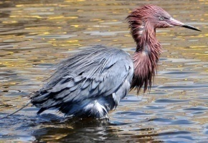O: Bolsa Chica Ecological Reserve Newcomer Hike**: Easy paced, reasonably flat, 5 mile hike, approx 3 hrs. Newcomers Welcome. Enjoy the natural beauty of Bolsa Chica, one of the last remaining wetland ecosystems in Southern California. Meet 8:30 am. From Warner Avenue in Huntington Beach turn south on Bolsa Chica Street to the end of the street and trailhead (Brightwater). Park on the street. Bring camera, water, sun protection, hat, light hiking boots, rain does not cancel. Ldrs: Houria Hall, Donna Specht, Julie Garner

**For complete up-to-date listings of Orange County Sierrans Section events go to: http://angeles.sierraclub.org/ocss**

SUNDAY, MAY 21,  3:00 PM PM OCSS

**La Mirada Symphony:**  Join us for a free classical concert at the La Mirada Theatre for the Performing Arts, 14900 La Mirada Blvd. La Mirada Ca. 90638, corner of Rosecrans and La Mirada Blvd. The Concert is Free, but donations are welcome. Meet the host 2:15 P.M. up stairs for a talk on the Symphony. Optional dinner later. Host: Fred Lazzelle 1-657-445-9063.

Wednesday, May 24, 9:00 AM OCG, OCSS

**O: Bear Canyon Loop:** 7 mi, 1000’ gain up from the Candy Store through chaparral and oaks and wildflowers, then up the ridge to 4 corners and back by shady Pigeon Springs. Meet 8:30 am at South Orange County rideshare point , or 9:00 am at the Candy Store on Ortega Hwy parking lot with Forest Service Pass. Bring 2 qts water, snack/lunch, hiking boots. Leaders: Mike Sappingfield. Asst: Sharon Kirk.

Friday, May 26 29  Wilderness Adv, OCSS

**bl00548_I: Memorial Day in Wawona Cabin Trip:** Rideshare Fri to stay in a cabin in the Wawona area near Yosemite's south entrance for moderately paced 8-12 mi, 1200'-3000' gain hikes each day. Not suitable for beginners or sightseers. Cost includes 3 nights lodging in modern cabin with all amenities (2-3 per bedroom with shared bathrooms and kitchen), 3 continental breakfasts, Sat Happy Hour, Sun group dinner. Send $275 (Wilderness Adventures - $40 cancel penalty, no refund of balance after 4/24 unless trip is full and suitable replacement found), 2 sase (or 1 sase and email), H&W phones, recent hiking experience to Ldr: Keith Martin, P.O. Box 336, Groveland CA 95321. Email: keithwmartin@sbcglobal.net. If you are interested in going on this trip you need to have a check in the leaders hands by April 24th if you want a chance of getting a couples room.  Asst Leader: Beth Powis Martin

Saturday, May 27, 9:00 AM OCSS

**O: Bommer Canyon, Irvine:** Easy pace, 4.8 mile loop, 250 feet gain, approximately 3 hours. The Bommer Canyon Trail is well maintained by the Irvine Conservancy with beautiful wild land views. Newcomers Welcome. Meet in the parking lot near the tennis courts, Turtle Rock Community Park, 1 Sunnyhill, Irvine CA. Bring Water, snacks or lunch, sun protection, hat, light hiking boots, camera. Rain cancel. Optional, after the hike, visit Turtle Rock Nature Center and have lunch in the park. Provisional Leader: Cherry Postic 714-990-9250 [cherwiski@hotmail.com](mailto:cherwiski@hotmail.com), Donna Specht

Saturday, June 3, 5:00 PM OCSS

Outings Planning Squaretable BBQ: Join Orange County Sierrans, everyone welcome. Come help plan, schedule an event, find a co-leader and coordinate events for the coming months. Bring your ideas. Meet the leaders. Learn how to plan your own event or how to become a leader. Remember you don't have to be a leader to host a social event. Volunteers welcome, lots of opportunities. Bring your laptops, we can sign on the the Chapter website and navigate online scheduling and post your event. How cool is that? We will provide the BBQ hot dogs. Bring a side dish and your favorite drink. RSVP to Donna Specht Specht 714-963-6345 (donnaspecht@juno.com) Location and directions provided. Leaders: Houria Hall, Karen Belville, Annie Simjee, Joel Kenyon

Sunday, June 04, 2017 8:30 AM   OCSS

**O: Bommer Canyon and Turtle Ridge, Irvine:** Hike An approximately 4 hour loop, moderately paced 6 mile round trip, 950' gain/loss hike up Bommer Canyon to Turtle Ridge (moderately strenuous steep steady incline to the ridge). Start the hike in open areas, little shade, view lush green hills on the way up Bommer Canyon and ascend to Turtle Ridge where you enjoy wide unobstructed vistas at top of Turtle Ridge. After about 2 miles on the ridge, descend back down steps to reach Shady Canyon pavement back to Turtle Rock parking. Essentials: Hiking boots, water, snack, hat, sunscreen, sunglasses. Meet 8:30 AM at Turtle Rock Community Park, corner Sunnyhill and Shady Canyon. Rain cancels. Leader: Ghia. Domont-Bohl, 949-719-2914 [gdbohl@gmail.com](mailto:gdbohl@gmail.com), Assistants: Joel Kenyon, Keith Bohl

Thursday, June 8, 5:30 PM RIO HONDO

**O: Fullerton East Coyote Hills Hike:** Join us for a cool evening 3-4 mile hike in the gentle East Coyote Hills in Fullerton. We alternate a couple routes. One is the Panorama Trail through Panorama Nature Preserve with great views of San Gabriel Mtns. Once we reach Brea Blvd, we follow the East Coyote Hills Trail back to Vista Park. Or we cross State College and hike at Craig Park, making a loop up to Brea Dam and enjoy the lake, ducks, egrets, squirrels, and more. Slow to medium pace is great for beginners. Meet at the lower Vista Park / Summit House parking lot (entrance on west side of State College Blvd. just south of intersection with Bastanchury Rd. in Fullerton). Wear sturdy shoes; bring water, flashlight. Rain cancels. Leaders: Alan Daniels, Sandy Viernes, Margee Hills, Houria Hall.

Saturday, June 10, 8:45 AM   OCSS

**O: Hellman Wilderness Park Ramble, Whittier:** Hike in the wilderness bordered by Rose Hills and City of Whittier. 6 miles round trip, 600' gain/loss. Optional steep switchback. Lunch in shaded grove. Bring hat, hiking boots, 2 qt water, lunch. Newcomers Welcome. Meet 8 am Long Beach Rideshare pointt, north side of 5800 Atherton St. (near Blue Pyramid) Long Beach, CA 90840 or 8:45, 5700 Greenleaf Ave trailhead, Whittier: from 605 Fwy North, exit Whittier Bl/CA-72. Right on Whittier, Left on Broadway, Left on Greenleaf. Leader: Richard Boothe, 562/446-5697, Co-leader: Joel Kenyon, Joel Kenyon, 949-285-5909 jkenyon2002@excite.com

Saturday, June 10 -11 OCSS

**O: San Jacinto Backpack to Round Valley:** Come and experience the wilderness of San Jacinto State Park via the Palm Springs Tramway (8420’). Enjoy the pine forests as we hike to Round Valley (2.1 miles), set up camp, and continue to Wellman Divide (9720’) and up Deer Springs Trail to San Jacinto Peak (10,834’) for 3.7 additional miles. This is a moderately strenuous hike with 2434’ gain. We will return to camp and enjoy happy hour Saturday night. On Sunday morning, we will hike back to the tramway. Bring money for tramway fee, backpack, tent, sleeping bag, pad, cooking gear, at least 4 liters of water, warm layered clothing, hiking boots, poles, 10 essentials, bear canister, and something to share for happy hour. Group size limited due to permit. Send recent conditioning and backpack experience to Provisional Leader Karen Belville, (karen.belville@gmail.com) Asst Leader: Fran Penn

Saturday, June 10, 8:00 AM Wilderness Adv, OCSS

**O: Buckhorn to Burkhart Saddle, Will Thrall Peak (7,848'):** Moderately strenuous stroll through mature forest down into a couple canyons whose creeks should be splashing through the woods, then up to Burkhart Saddle for a great view of the Mojave Desert. From here, climb up to seldom-visited Will Thrall Peak (may include brief off-trail scrambling). Hike is about 12 miles and 3,100 feet gain, and will go at a moderate pace. Wear hiking boots, 10 essentials, including lunch and at least two quarts of water. Meet by 8:00 AM at La Canada Ride Share - Angeles Crest Highway (Hwy 2), Just N of Foothill Fwy (I-210). Cars parked in Angeles National Forest will need to display Adventure Passes. Leaders: Mark Alan Mitchell 818-753-9328 markamitchell@att.net

Dean & Benita Wallraff 818-353-4268 dw@aenv.org

Wednesday, June 14, 2 7:15 AM   OCG, OCSS, Sierra Sage

**O: Bighorn Peak: Bighorn Peak (8440’):** Join us for a 10 mi, 3600’ gain hike in the San Gabriel Mtns along an inviting creek, past private cabins and through beautiful forests to Ice House Saddle and on up to Bighorn Peak, on the 100 peaks list. Meet 7:15 am at the Tustin Rideshare (one block South of I-5 on Redhill in the portion of the parking lot at the Stater Bros strip mall the extends behind the Union 76 gas station). Bring 2+ liters water, lunch/snacks, hiking boots, poles. Ldr: Sylvia Stevenson Linda Ledger (linda.ledger@me.com)

Sunday, June 18, 8:30 AM OCSS

**O: Bolsa Chica Ecological Reserve Newcomer Hike**: Easy paced, reasonably flat, 5 mile hike, approx 3 hrs. Newcomers Welcome. Enjoy the natural beauty of Bolsa Chica, one of the last remaining wetland ecosystems in Southern California. Meet 8:30 am. From Warner Avenue in Huntington Beach turn south on Bolsa Chica Street to the end of the street and trailhead (Brightwater). Park on the street. Bring camera, water, sun protection, hat, light hiking boots, rain does not cancel. Ldrs: Houria Hall, Karen Belville, Dorothy Gutierrez, Steve Bradford

Wednesday, June 21, 9:00 AM OCG, OCSS

**O: Buck Gully:** 5 mi, 100’ gain. Explore this sylvan wilderness along a stream with elegant bridges in Corona del Mar. Meet 9:00 am at the corner of Poppy and 5th Av, E of PCH on Poppy in Corona del Mar. Park on street. Bring water, walking shoes, snack. Ldrs: Sylvia Stevenson, Sharon Kirk

Wednesday, June 28, 9:30 AM OCG

**O: End of Season/Potluck Aliso Wood Canyon: Aliso/Wood Canyon Regional Park**: 5-7 mi, min gain loop hike on the East Aliso Creek Trail. Bring water, hiking boots. Bring a dish for 4-6 to share, plus your own plate, cup, utensils, drink. Meet 9:30 am at the Aliso Wood parking lot (from Alicia Pkwy, S to just past Aliso Creek Rd, turn R into Awma Rd and the parking lot. $3 parking. Ldr: Sherri Sisson. Asst: Pete Height.

Wednesday, August 02 - 06 MULE PACK, OCSS

**O: Cottonwood Lakes Mule Pack:** Join us as hired packers carry gear of 45 lbs per person while we hike separately with only our daypacks. Wednesday am hike from Cottonwood Pack Station (10,040') at Horseshoe Meadows, 6.5 mi, 1,300' gain, to camp in the upper South Fork Lakes area of Cottonwood Lakes with beautiful views of Cirque Peak (12,900'), Mt Langley (14,026') and surrounding areas. Thursday -Saturday hike, photo, fish, or relax in camp. Can we find Hidden Lake? Enjoy happy hours every night with wine provided followed by a group potluck dinner. Sunday we hike out. $375. To apply, email/call with recent high altitude and distance conditioning to Leader: Fran Penn, 714-747-1019 [oldhikergirl@yahoo.com](mailto:oldhikergirl@yahoo.com), Asst: John LaRue

Saturday, September 30 - October 01 OCSS

**O: Harwood Lodge Fall Festival:** Enjoy clear mountain air, hiking, music, relaxation, blue skies and beautiful mountain views and celebrate the beginning of Fall at Harwood Lodge. Musicians bring your instruments. Newcomers welcome. Includes hikes to the Waterfall and a special Geology hike with Jay Schneider. Includes Saturday and Sunday hikes, Happy Hour, lodge fees, Saturday night dinner. Sunday breakfast, hike, shared chores and check out by 3pm. http://angeles.sierraclub.org/harwood\_lodge Send 1 self addressed stamped envelope OR e mail address, phones, address, carpool info, $60 with Sierra Club# or $75 non-member (check payable OCSS to Reservationist/ Co Leader: Donna Specht, 22221 Wood Island Lane, Huntington Beach, CA 92646. Leaders: Richard Booth, Jay Schneider

**For complete up to date listings of Orange County Sierra Singles events go to:http://angeles.sierraclub.org/ocss**

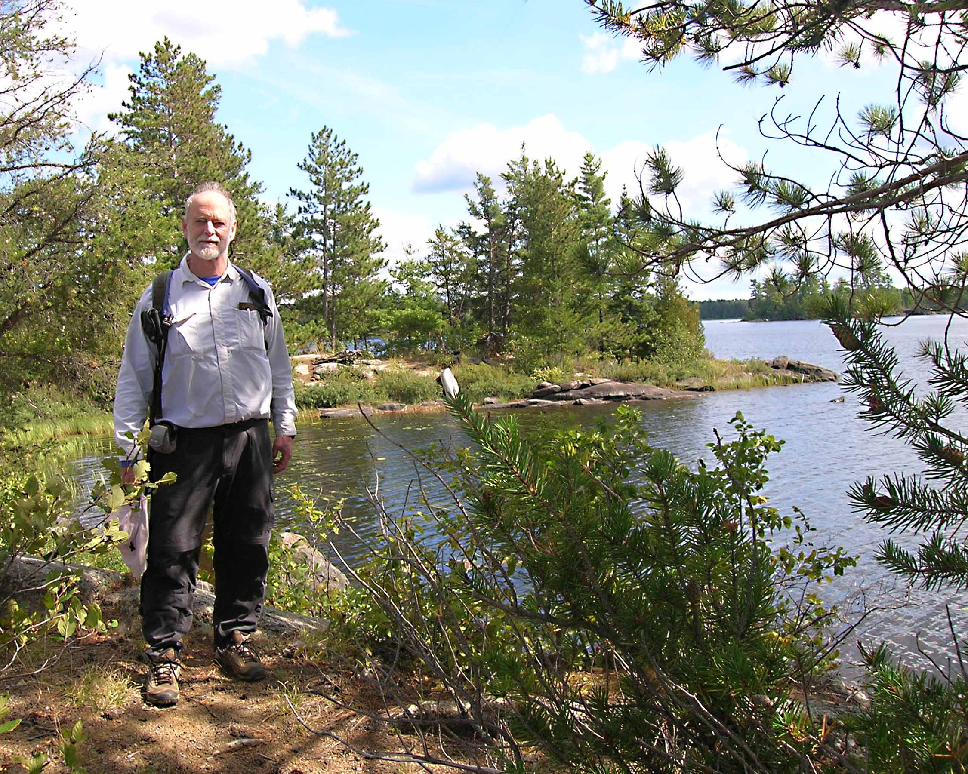

**Chapter Awardee Brooks Chadwick, Canoeing Boundary Waters.**

A Note on Phone Etiquette…

When Calling a Team member, leader or host, please call between 9 AM and 9 PM only, **unless the write-up states otherwise.** Remember E-mail, the silent call! Very Much appreciated by all! Thanks to our active OCSS leaders and hosts

|  |  |  |
| --- | --- | --- |
| Abele, Kathy  Abele, Kathy | O | 949-951-0280 |
| Bartlett, Bart | O | 714-968-5099 |
| Bartlett, Shilo | O | 714-809-5099 |
| Belville, Karen | O | 310-486-8583 |
| Botan, Steve | O | 714-321-1296 |
| Bradford, Stephen | O | 310-993-5501 |
| Cadez, Ana | OW | 626-836-2235 |
| Campbell, Ron | M | 714-962-8521 |
| Clark, Todd | I | 714-803-0195 |
| Clement, Dick |  | richsea@sbcglobal.net |
| Closson, Scott | O | 714-457-6820 |
| Côté, Sylvie | I | 949 547-2998 |
| Creighton, Barbara | O | 714-960-3949 |
| Dodson, Michael | MW | 714-529-6020 |
| Dodson, Phyllis | OW | 714-529-2440 |
| Domont-Bohl, Ghia | O | 949-719-2914 |
| Fleming, Mark | IW | 626-712-3671 |
| Forry, Harry | OW | 714-962-4136 |
| Franciosi, Laura | O | 714-879-1760 |
| Frankiewicz, Ron | O | 949-631-8071 |
| Garner, Julie | O | 714-335-1579 |
| Geller, Charles | O | 714-292-2352 |
| Graham, Sandy | OW | 714-282-5661 |
| Graham, Scott | O | 714-282-5661 |
| Hall, Houria | O | 714-767-5327 |
| Hills, Margie | O | 714-256-0807 |
| Huang, James | O | 949-287-4455 |
| Johnson, Jerry | O | 626-484-2983 |
| Juarez, Ana | O | 714-323-3627 |
| Kenyon, Joel | O | 949-285-5909 |
| Khoshab, Karim | O | 949-559-1388 |

**Please Join us on our MEDIA sites!!**

**http://www.meetup.com/Orange-County-Sierra-Singles/**

**http://www.meetup.com/Orange-County-Sierra-Singles-20s-30s-40s/**

**Sierra Club Angeles Chapter: http://angeles.sierraclub.org**

**Like us on Facebook: http://www.facebook.com/ocsierrasingles**

**For a complete list of Angeles Chapter Travel Adventures go to:**

**http://angeles.sierraclub.org/get\_outdoors/travel\_adventure**

**Follow Angeles Chapter Travel Adventures on Facebook**

[**https://www.facebook.com/SierraClubAngelesTravel**](https://www.facebook.com/SierraClubAngelesTravel)

|  |  |  |
| --- | --- | --- |
| Kirk, Sharon | O | 714-376-3197 |
| Kuhn, Dave | I | mtndave@cox.net |
| Lamb, Fred | O | 949-350-6451 |
| Lai, Frank | O | 949-262-1448 |
| LaRue, John | O | 949-854-7919 |
| Lazzelle, Fred | H | 714-870-4469 |
| Le, Kenadi | O | 818-445-2333 |
| Lejins, Diana | O | 562-421-8012 |
| Lyons, Gaines | O | 562-491-2022 |
| Martin, Keith | MW | 310-530-1268 |
| Maynard, Joe | O | 562-981-9111 |
| Meek, Scott | IW | 909-393-0630 |
| Mitchell, Mark | IW | 818-753-9328 |
| Montgomery, Norm | O | 714-557-0794 |
| Nemmert, Jan | OW | 714-962-4136 |
| Opperman, Sanford | H | 714 993-0651 |
| Palmer, Jim | O | 949-551-8912 |
| Penn, Fran | I | 714-747-1019 |
| Puraty, Sharry | O | 714-761-8761 |
| Sharp, Gwen | IW | 714-672-9525 |
| Smith-Meek, Julie | IWC | 909-393-0630 |
| Specht, Donna | IWC | 714-963-6345 |
| Talbott, Virgil | EW | 714-871-7900 |
| Thio, Kwee | O | 714-841-7988 |
| Van Strien, Maura | O | 714-962-3166 |
| Weinreich, Phil | O | 949-733- 2730 |

|  |  |
| --- | --- |
| Orange Peal Deadlines | |
| Write ups Due | ISSUE |
| Feb 1 | Mar/Apr |
| Apr 1 | May/June |
| June 1 | July/Aug |
| Aug 1 | Sept/Oct |
| Oct 1 | Nov/Dec |
| Dec 1 | Jan/Feb |

|  |  |  |
| --- | --- | --- |
| **OCSS Management Committee** | | |
| Chair | Joel Kenyon | houriazhall@yahoo.com |
| Vice Chair/Secy | Houria Hall | EduRight@aol.com |
| Outings/Treasurer/Membership | Donna Specht | donnaspecht@juno.com |
| Secretary | Karen Belville | Karen.Belville@gmail.com |
| 20's/30's/40s | Scott Closson | sclosson0@icloud.com |
| At Large | Jay Schneider | rtnttnj@aol.com |
| Database Assist. | Annie Simjee | annebotz6@gmail.com |
| **Standing Committees** | | |
| Bookkeeper | Ron [Frankiewicz](file:///C:\Users\Dick\AppData\AppData\AppData\AppData\Roaming\Local%20Settings\WINDOWS\Desktop\standing%20committees.doc) | Upon request |
| Mailout | Barbara Creighton | bcreighton@socal.rr.com |
| Backpacking | Fran Penn |  |
| Nominations | Kathy Abele | KatHiker@cox.net |
|  | John La Rue | jclarue@cox.net" |
| Elections | Virgil Talbott | virgil\_talbott@roadrunner.com |
|  | Howard Huang | hh99usa@yahoo.com |
| Safety | Ron Campbell | campbellr@verizon.net |
| Newsletter Editor | Dick & Paula Clement | richsea@sbcglobal.net |

**ORANGE PEAL SUBSCRIPTION INFORMATION**

**New Subscriptions/Address Changes:** Please complete the form below and mail. Inquiries or Problems: Please address inquiries in writing to OCSS, ℅ Joel Kenyon, 27492 Los Banos, Mission Viejo, CA 92691. Contact the Membership Chair if you have any questions.

|  |
| --- |
| ***OCSS* Orange County Sierrans Section**  **℅ Joel Kenyon, 27492 Los Banos, Mission Viejo, CA 92691**  ***Orange Peal Subscription Form*** |
| Name: \_\_\_\_\_\_\_\_\_\_\_\_\_\_\_\_\_\_\_\_\_\_\_\_\_\_\_\_\_\_\_\_\_\_\_\_\_\_\_\_\_\_\_\_\_\_\_\_\_\_\_\_\_\_\_\_\_\_\_\_\_ |
| Address: \_\_\_\_\_\_\_\_\_\_\_\_\_\_\_\_\_\_\_\_\_\_\_\_\_\_\_\_\_\_\_\_\_\_\_\_\_\_\_\_\_\_\_\_\_\_\_\_\_\_\_\_\_\_\_\_\_\_\_ |
| City:\_\_\_\_\_\_\_\_\_\_\_\_\_\_\_\_\_\_\_\_\_\_\_\_\_\_\_\_\_\_\_\_\_ State: \_\_\_\_\_\_Zip\_\_\_\_\_\_\_\_\_\_\_\_\_\_\_ |
| Phone No: (\_\_\_\_\_)\_\_\_\_\_\_\_\_\_\_\_\_\_\_\_\_\_\_\_\_\_\_\_\_\_\_\_\_\_\_ |
| E mail: \_\_\_\_\_\_\_\_\_\_\_\_\_\_\_\_\_\_\_\_\_\_\_\_\_\_\_\_\_\_\_\_\_\_\_\_\_\_\_\_\_\_\_\_\_\_\_\_\_\_\_\_\_\_\_\_\_\_\_  Sierra Club #:\_\_\_\_\_\_\_\_\_\_\_\_\_\_\_\_\_\_\_\_Expiration Date: \_\_\_\_\_\_\_\_\_\_\_\_\_\_\_\_\_\_\_\_\_ |
| **Subscription Categories**  SC Member one year\* $12 SC Member two years\* **$22**  SC Member three years\* **$30** NonMember **$17** |
| New **Check#**: \_\_\_\_\_\_\_ |
| Renewal  Change of Address  Thank you for your Membership! Remember to Renew your Sierra Club Membership. |
| \*All $12 memberships must include Sierra Club Number |

**Why join the Sierra Club?**

**Because we need you!**

**Your voice will be added to those of more than 600,000 of your fellow Americans who are committed to leave our children a living legacy — clean air, clean water, and natural grandeur.** The Sierra Club has been instrumental in preserving wilderness, wildlife and nature's most splendid wild places for over 100 years — Yosemite National Park, Grand Canyon National Park, the Florida Everglades and the Sequoia National Monument to name just a few — helping protect over 150 million acres of wilderness and wildlife habitat.

**The Sierra Club is America's most effective advocate for the environment and helps you protect the environment locally and globally.** From community issues and action to lobbying on a national level, membership helps you take action where it's needed most. As a member you'll have opportunities to get involved with local chapters, as well as be part of the largest national network of environmental advocates. You'll have the satisfaction of helping preserve irreplaceable wild lands and wildlife. **Your membership counts!**

**So please — Join the Sierra Club today!**

**And remember to Renew!**

**Or go online to join:**

**http://angeles.sierraclub.org/ocss**