**Check Out Our Schedule Of Activities In This Issue.**

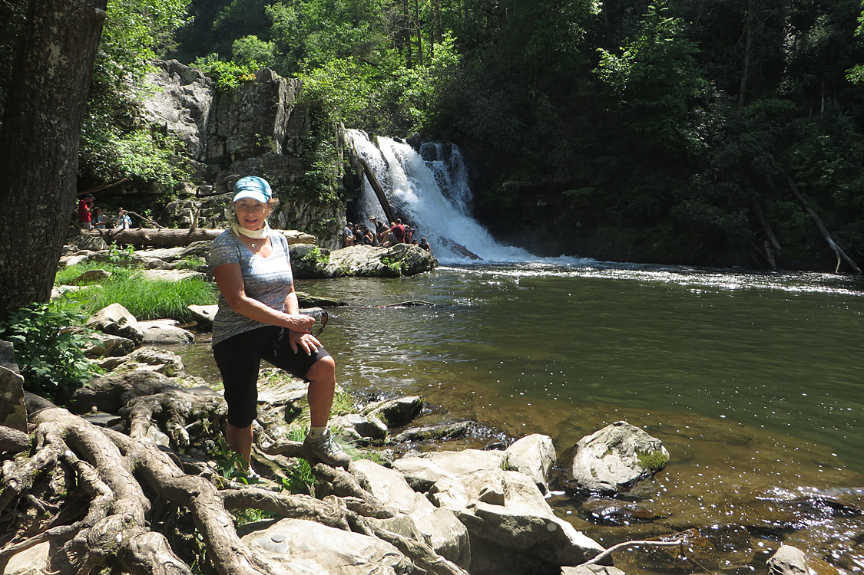**What are our members doing? Silvia Stevenson, Hiking Smoky Mountains, Tennessee**  **Photo by Donna Specht**

**Newcomer Member/Meet & Greet Special Events**

**Conditioning Hikes & Local Hikes**

**Hike for Conservation – Bolsa Chica Ecological Reserve,**

**203040s Events & Family Events**

**Travel Adventures: Destination~ Costa Rica**

**Check our website for complete Schedule:**

**http://angeles.sierraclub.org/ocss**

**SATURDAY, OCTOBER 1-14, 2016 ANGELES CHAPTER, OC SIERRANS**

**SIERRA SAGE**

**O: Destination Costa Rica:** Fourteen day tour from the Pacific beaches to the wild Northern Caribbean with stops at Manuel Antonio, Monteverde/Santa Elena, Arenal, Tortuguero and San Jose. Why watch a National Geographic special when you can live it? On layover days, hike and explore why this country is known for its enlightened approach to conservation. Visit Volcanoes, rain forests, ecological reserves, wildlife refuges. Spend 3 special days in Tortuguero Village where the first awakening of sea turtle conservation began.

Sierra Club Member cost $1950, Non member cost $2050 includes mid range locally owned accommodations (double occupancy), private 22-passenger air-conditioned coach, all breakfasts, happy hours, round trip boat transportation to Tortuguero, driver gratuities and 3 eco tours.

Group airfare extra. For itinerary, application, cancellation policy contact Co Ldr:Donna Specht, donnaspecht@juno.com. Ldr: Mike Sappingfield.

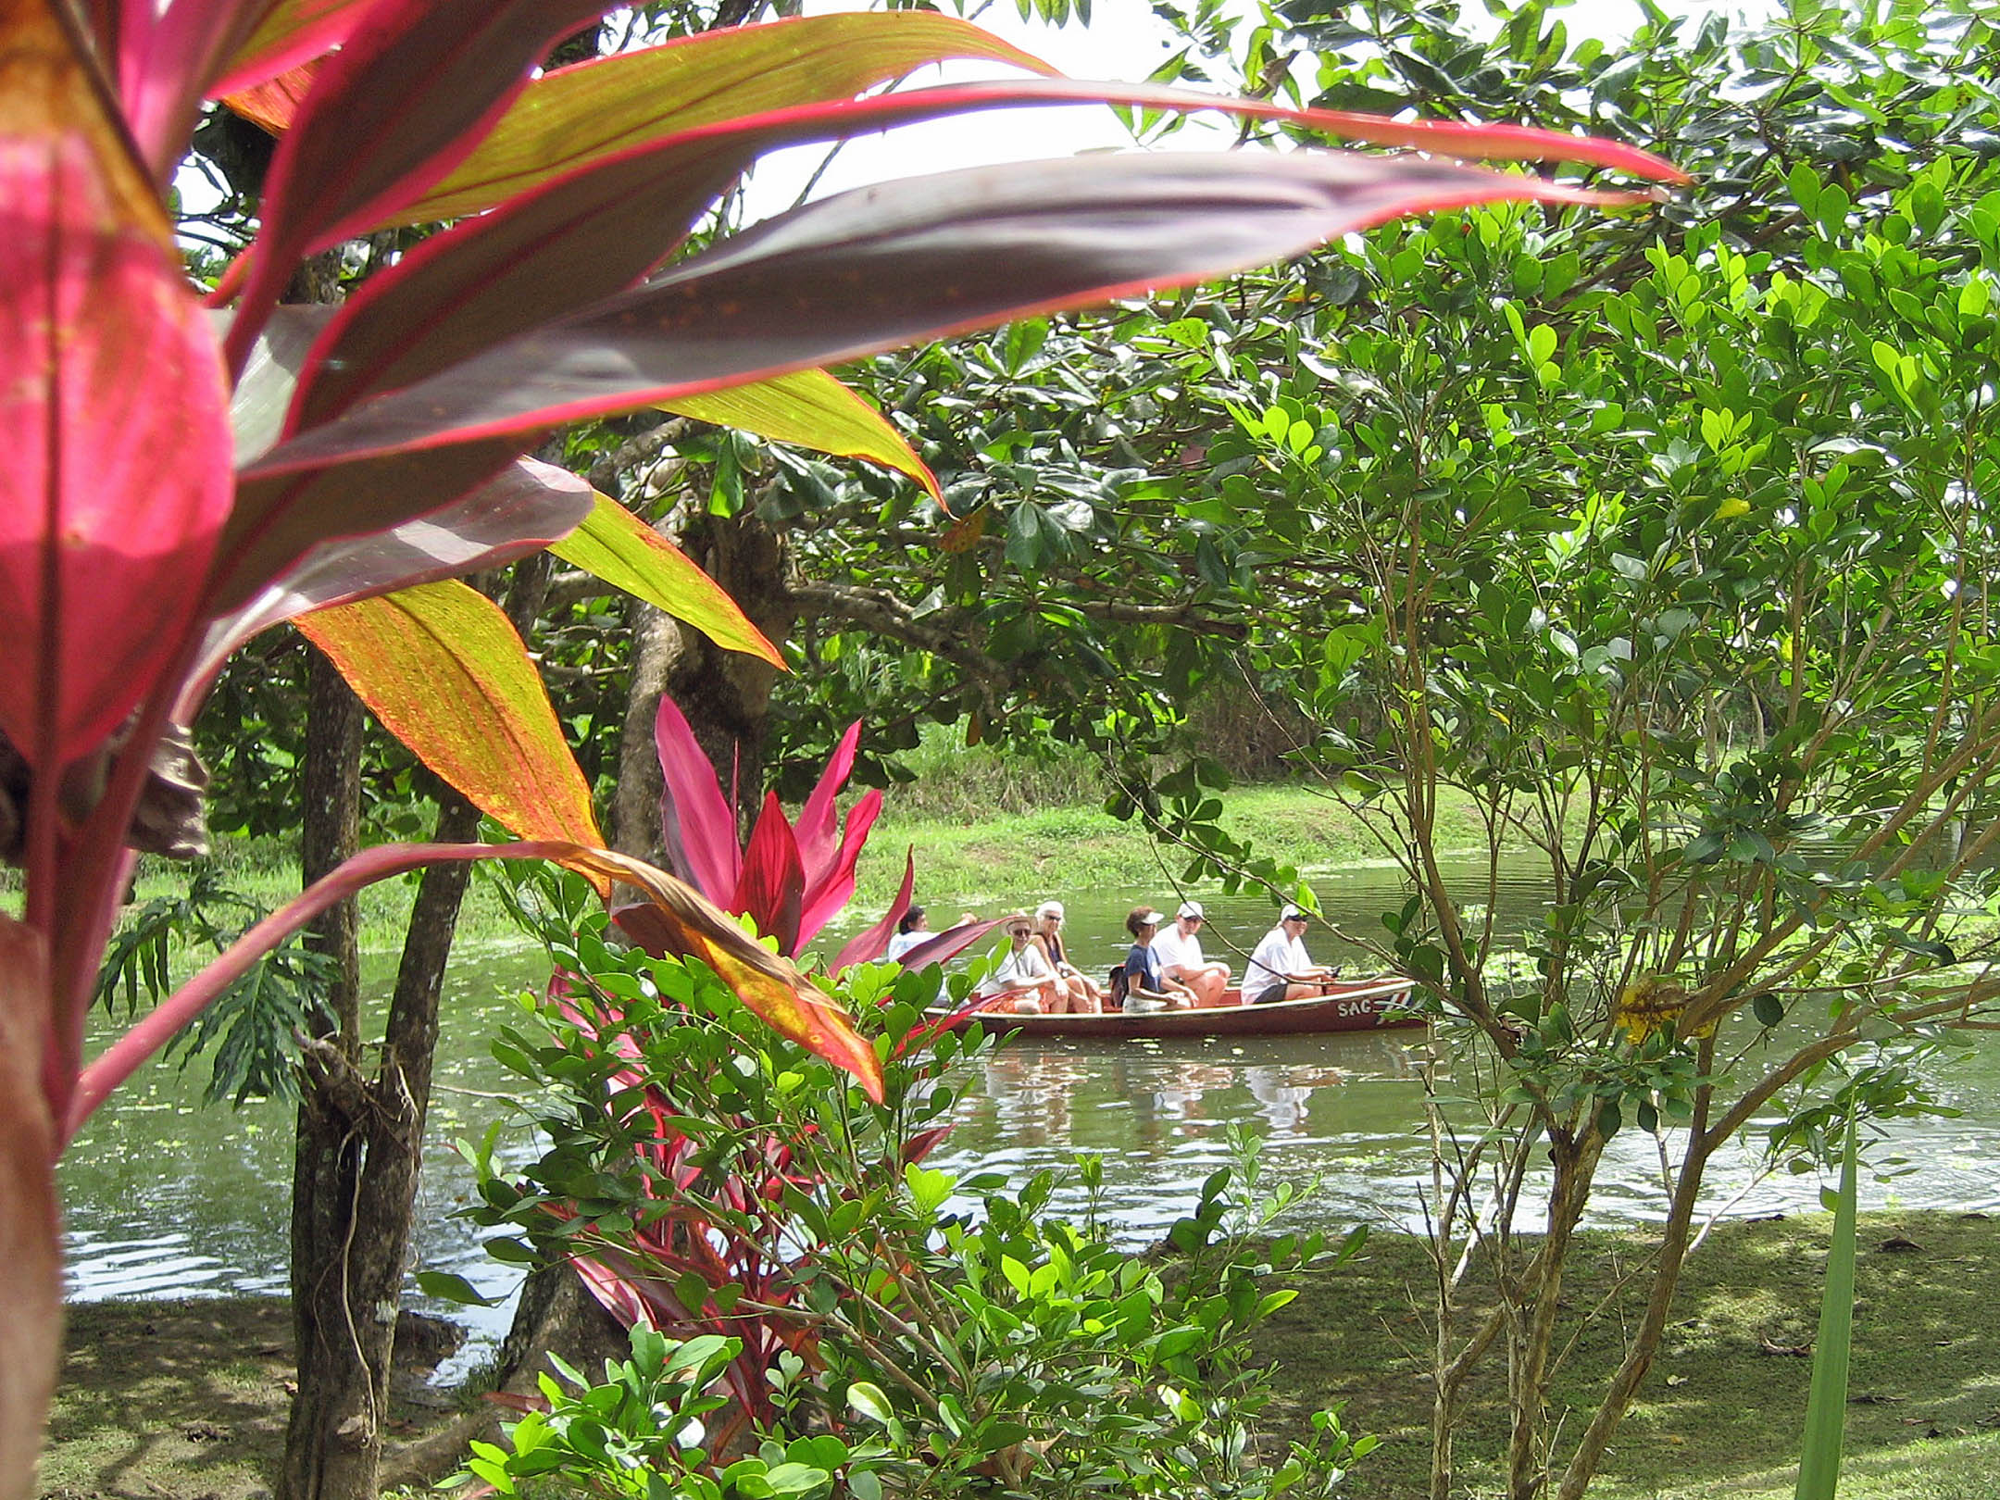

**Sloth Rescue Center, Cahuita, Costa Rica Photo by Donna Specht**

For complete up to date listings of Orange County Sierrans Section events go to: http://angeles.sierraclub.org/ocss

**Like us on Facebook:** [**http://www.facebook.com/ocsierrasingles**](http://www.facebook.com/ocsierrasingles)

**Sierra Club Angeles Chapter**

**Annual Awards Banquet**

**June 5, 2016**

**Brookside Country Club, Pasadena**

**Santa Ana Mountains Task Force Trail Maintenance Team** is honored with the **Extraordinary Achievement Award**.   The Santa Ana Mountains Task Force (SAMTF) has been in existence for at least 15 years. Its purpose is to protect the Santa Ana Mountains and the San Mateo Canyon Wilderness Area from misuse and to allow all Sierra Club members the ability to enjoy and explore the magnificent Santa Ana Mountains. The SAMTF established a trail maintenance program in the San Mateo Canyon Wilderness in liaison with the Trabuco District of the Cleveland National Forest and they have done a superb job. On December 30, 2014, a major storm hit the Santa Ana Mountains and dropped up to 12 inches of snow. Every hiking trail was impacted due to fallen trees, fallen branches and uprooted chaparral; many of the most popular trails were impassable. The SAMTF Trail Maintenance Team became aware of the tremendous damage shortly thereafter and by the 2nd of January, an emergency plan was in place. The plan mobilized hikers and trail maintenance regulars in the SAMTF, which includes the Orange County Group, the Sierra Sage Group and the San Gorgonio Chapter. They were asked to work every Saturday and Wednesday until the crisis was over. This they did. In total, 36 volunteers worked 11 special work days, totaling 930 work hours. Within 3 work days, the previously impassable trails were open and by the end of January most of the trails were back in hiking condition and by the first weekend in March the crisis was over and the trails were open.

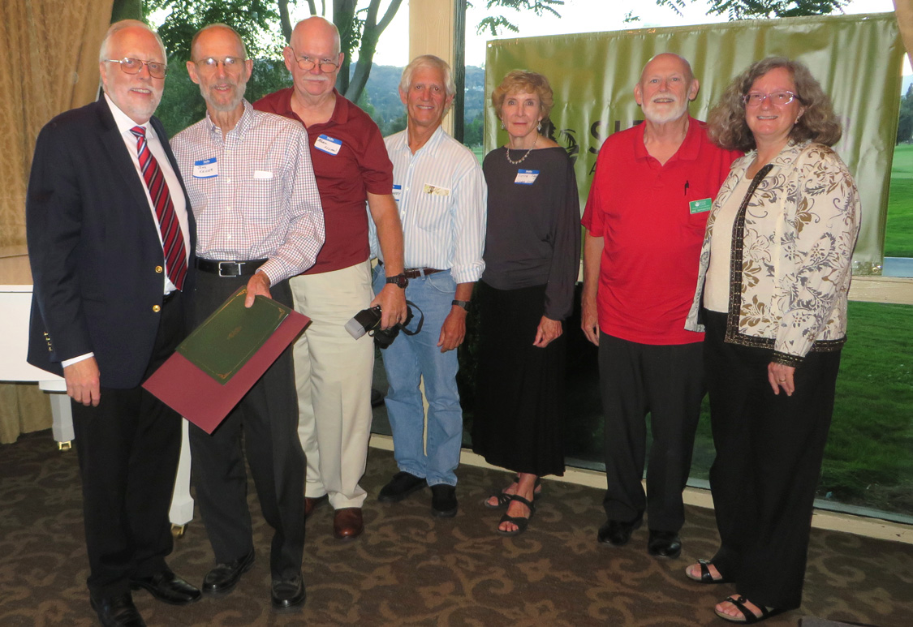

**OCSS members, Rich Maxey and Linda Ledger between Chapter Senior Development Director, George Watland, from the left John Kaiser, Mike Sappingfield and past Chapter Chair Carole Mintzer**

**MEMBERS IN THE NEWS**

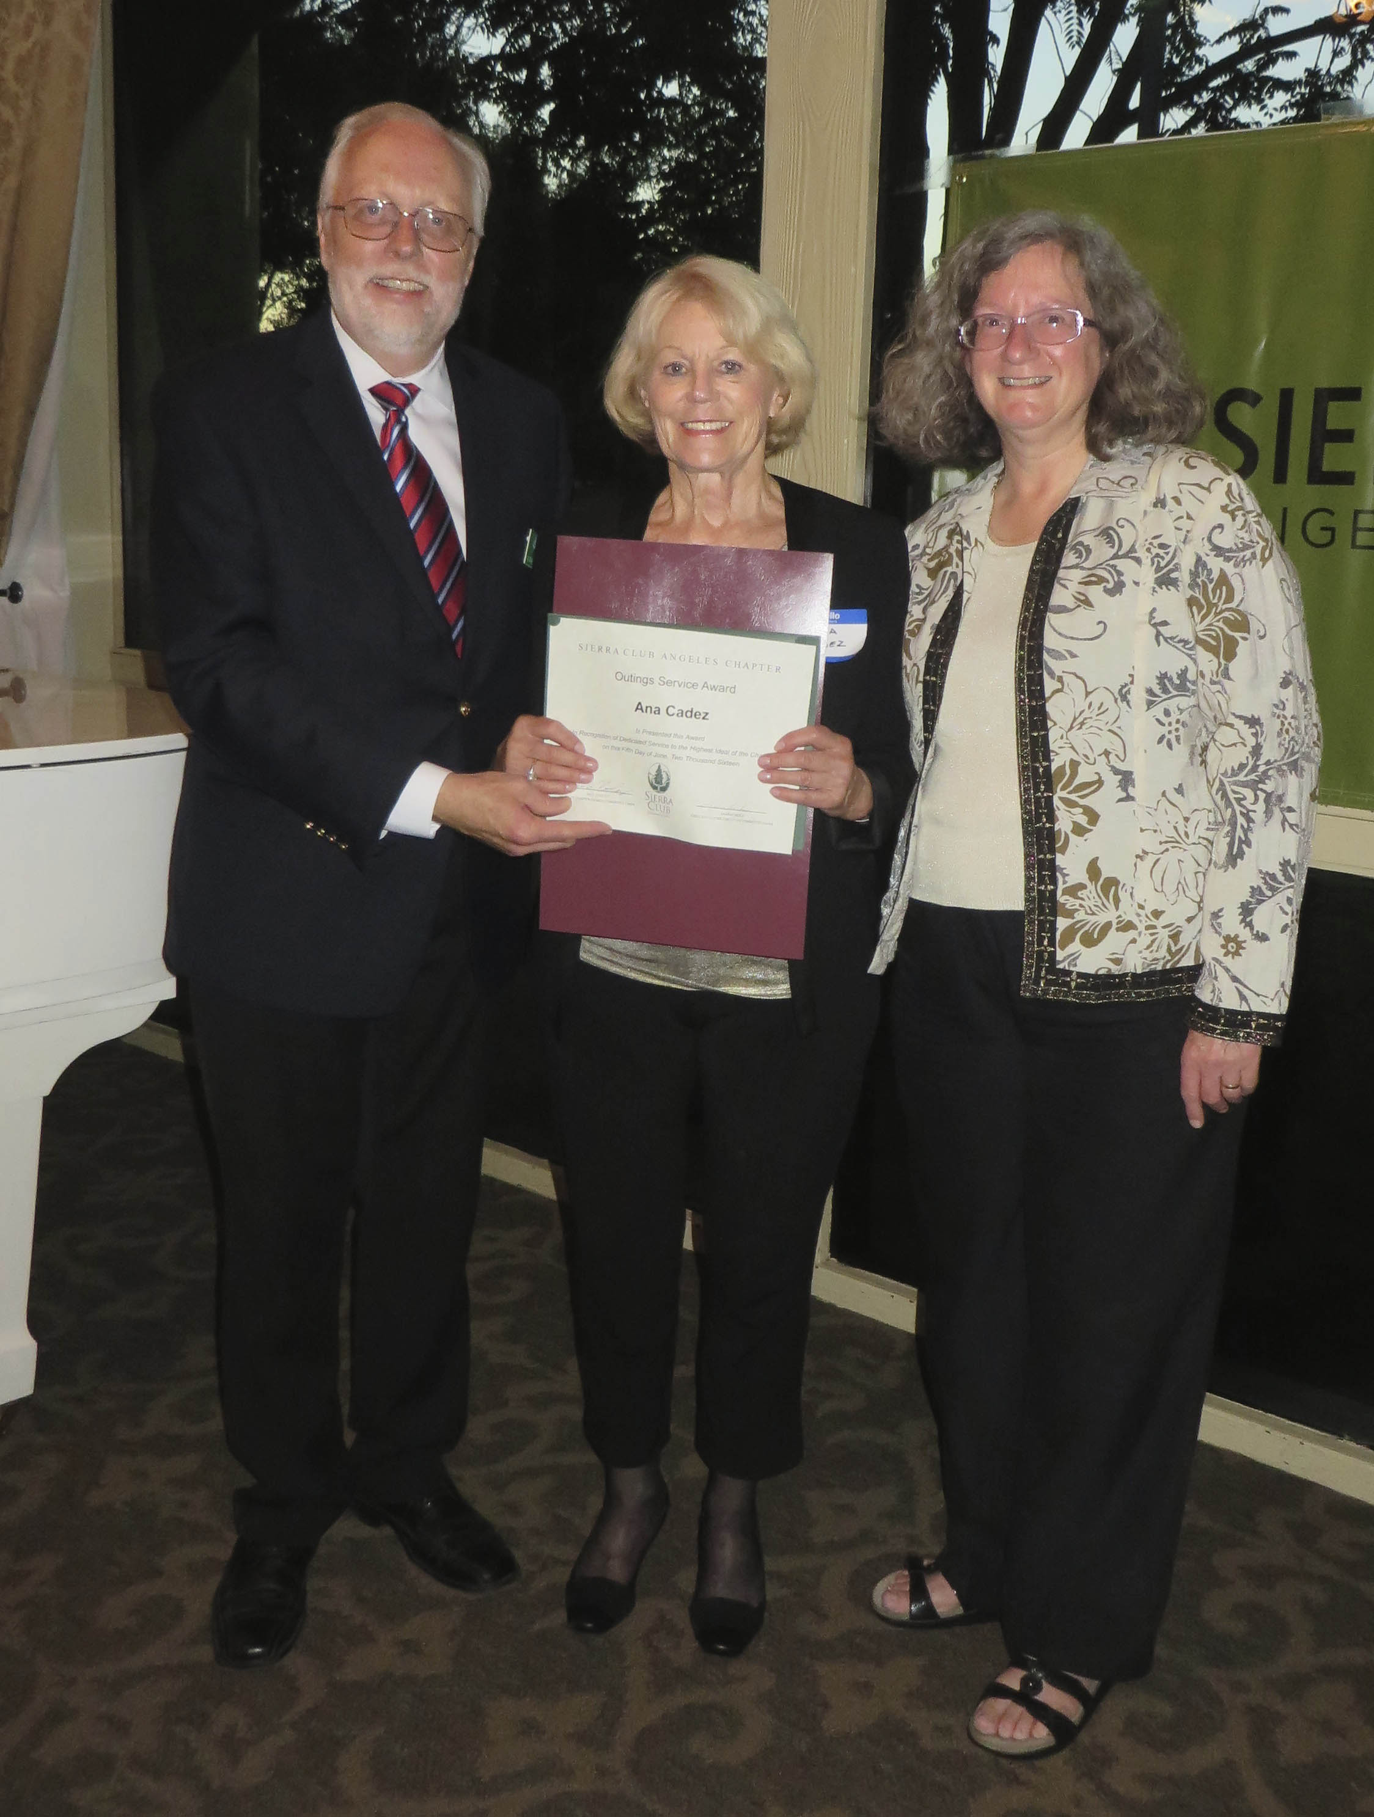

**Outings Service Awardee, Ana Cadez**

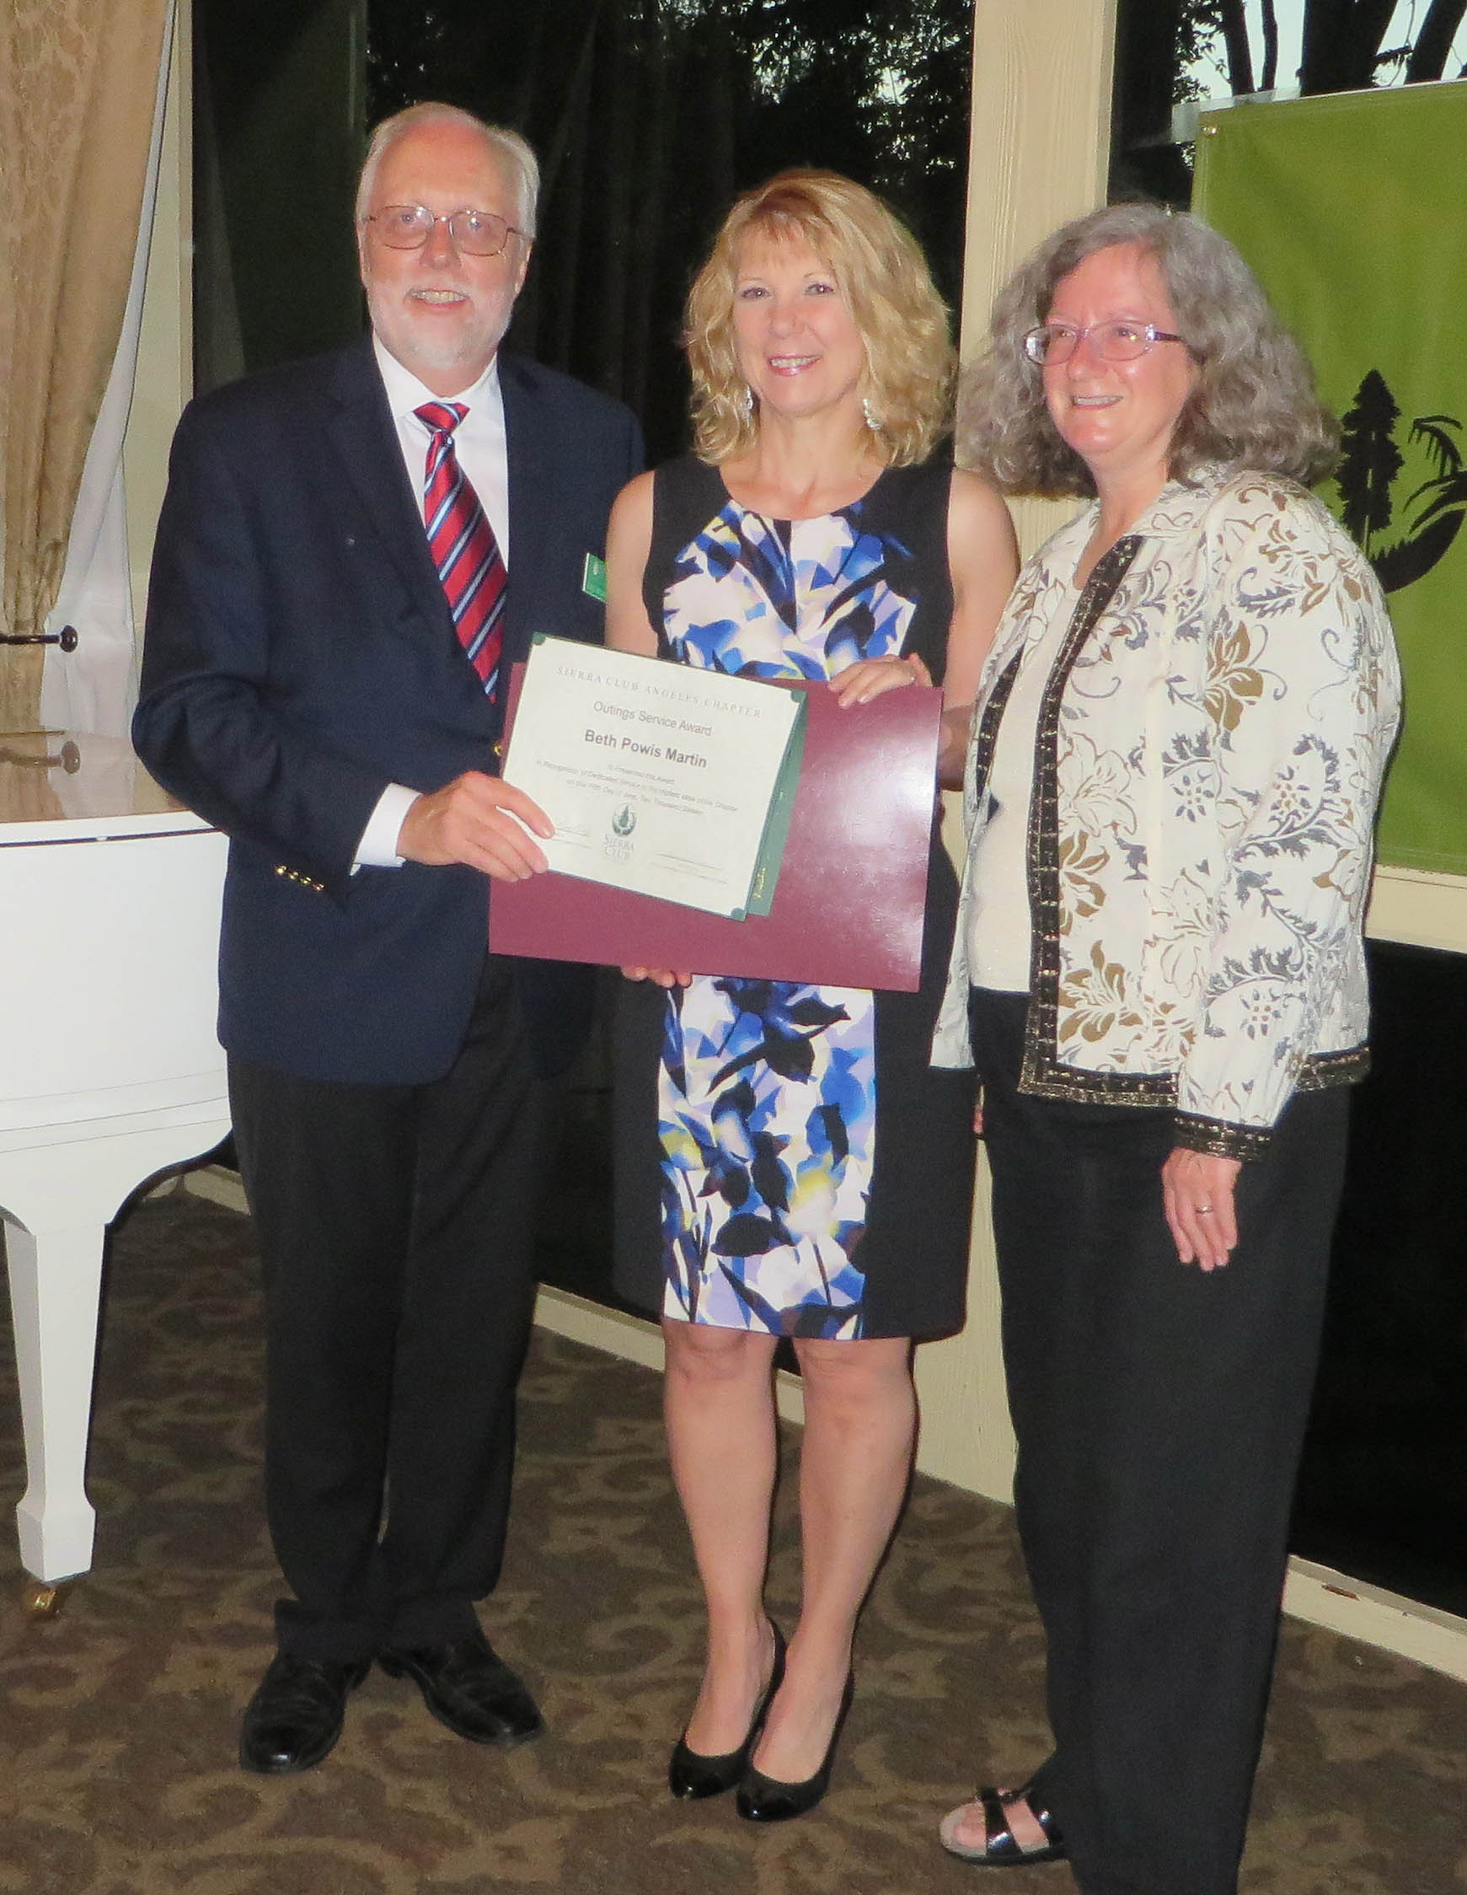

**Outings Service Awardee, Beth Powis Martin**

**Special Awardees with Chapter Senior Development Director, George Watland, and past Chapter Chair Carole Mintzer Photos by Donna**

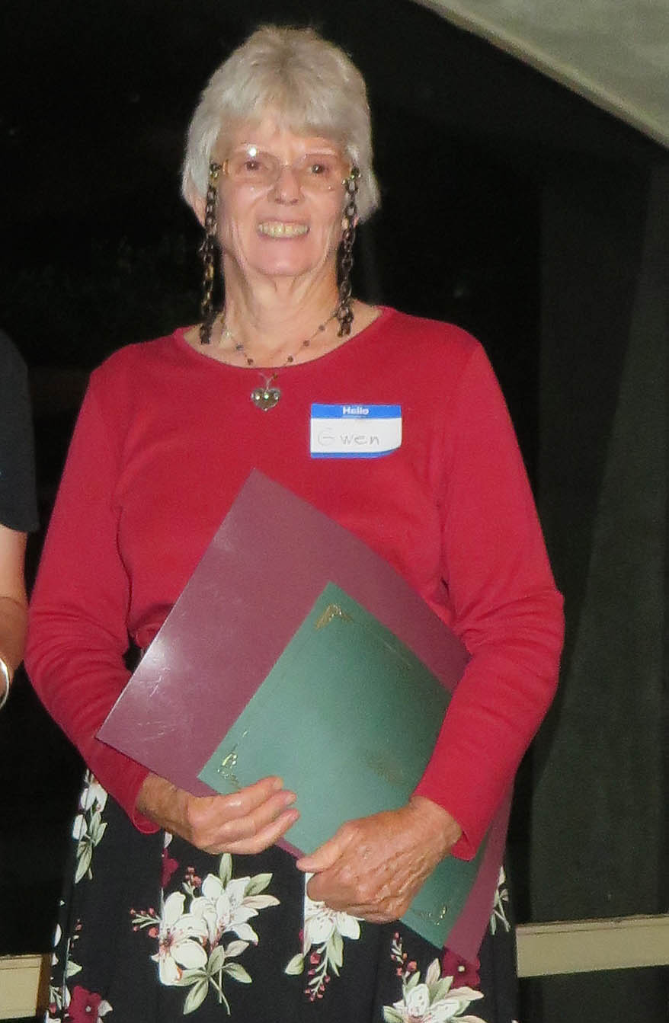

**Outings Service Awardee, Gwen Sharp**

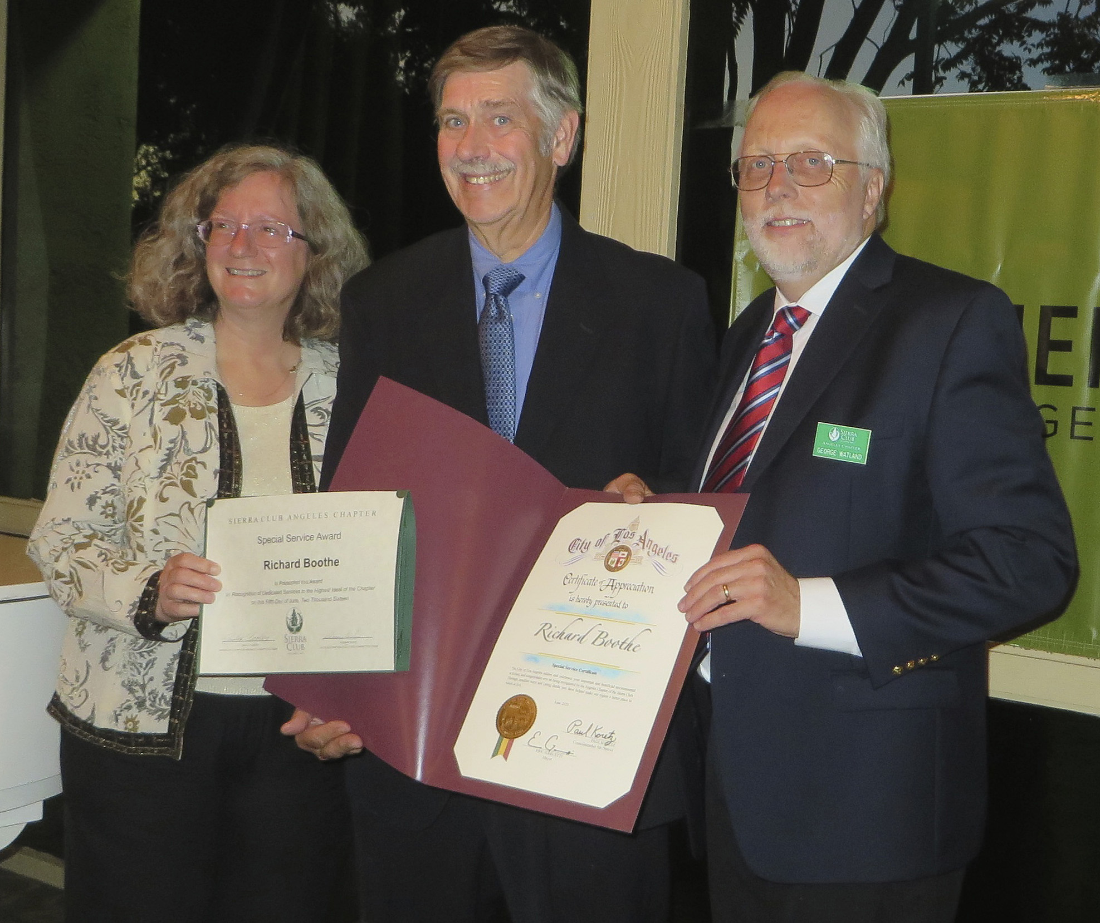**Special Service Awardee, Richard Boothe**

WED, JULY 20 7-9:30 pm MGMNT COMMITTEE MTG

Open to all members. Meeting starts at 7PM. Guests must request to be on the agenda if they wish to make a presentation. Guest Agenda items must be submitted one week in advance to Vice Chair Charles Geller . eduright@aol.com **Contact Donna Specht for location and directions to the meeting.**

wed, AUGUST 17 7-9:30 pm MGMNT COMMITTEE MTG

ON VACATION, NO MEETING**.**

MONDAY, AUGUST 8, 6:30 PM ANGELES CHAPTER, OCSS

**Meet/Greet/Newcomer/Member Special Event:** Come and discover the Sierra Club. Be a part of the largest grassroots environmental organization in the country. Sierra Club outings provide environmentally friendly outdoor adventures from Costa Mesa to Costa Rica for all ages. Come and meet representatives and leaders from conservation beach walks to peak bagging. Table displays, exhibits, refreshments. Join Sierra Club $15 Special Offer, free gift. Meet at the Costa Mesa Community Center, 1845 Park Ave, Costa Mesa. Contact Chapter Membership Chair: Donna Specht.

**PROGRAM**

Monday, November 14, 6:30 PM   Angeles Chapter, OCSS

**[](http://www.clipartpanda.com/clipart_images/christmas-turkey-clipart-5900901)Newcomer/Member Meet Greet Eat, Thanksgiving Night:** We invite you to an activity packed evening: Introduction of our new leaders, Free Drawing, find out all about our events with 20s/30s/40s, our award winning Weekly Conditioning Hikes, Social activities, conservation outings and Adventure Destinations and Winter Sports Program. Chance to purchase Sierra Club logo daypacks and other cool gifts. Newcomers welcome! Meet 6:30 pm, Costa Mesa Neighborhood Community Center, 1845 Park Avenue, Costa Mesa. $5 Donation. Optional, bring a Thanksgiving side dish, potluck item and we will provide the turkey, fixins and drinks. Join Sierra Club @ special introductory offer $15 and receive a free gift! Bring A Friend! Contact: Donna Specht (donnaspecht@juno.com)

TUE & THU 6:30-8:00 PM IRVINE CONDITIONING HIKES

**MC900157205[1]O: Easy/Moderate/Tiger paced hikes,** 4-7 mi rt on hilly trails. Bring water, light hiking boots. 405 Fwy, exit S at University/Jeffrey, L on Ridgeline, L on Turtle Rock, pass Sunnyhill, L into parking lot of Turtle Rock Community Park. Ldrs: John La Rue, Phil Weinreich, Joel Kenyon, Fran Penn, Fred Lamb, Jim Palmer, Donna Specht, Maura Van Strien, Karim Khoshab, Norman Montgomery, Shaune Hand, Michael Mavrovouniotis, and Christine Dickey.

**TUE 6:30 PM OCSS, RIO HONDO**

**O: Fullerton Beginners Hike:** Hike with our social group on this regular weekly beginner's hike of 4-5 miles in the gentle hills of Fullerton. Slow to medium pace is great for beginners. Each week we rotate through numerous trails in the area to provide new experiences. Optional dinner afterwards. Last Tue. of each month we have a potluck dinner. **Hike scheduled during daylight savings time, i.e. March through Oct.** Meet at the east end of Laguna Lake in Fullerton (from Harbor Blvd, W on Hermosa Dr, L on Lakeside Dr for ½ block and park on the street). Look for hikers on east side of Lakeside Dr. Wear sturdy boots, bring water, flashlight. Leaders: Martin Kluck, Joel Ortmann, Margee Hills, Houria Hall, Alan Daniels, Ed Khatch. Host: Sanford Opperman

SAT 8:00 AM PETERS CANYON CONDITIONING HIKES

**O:** Fast paced conditioning hike, 6 mi RT, 700' gain. No beginners or Tigers! From 5 Fwy, N on Jamboree, or from 55 Fwy E on Chapman. Take Canyon View into parking area. Bring water, lugholes, $3 for parking or have permit. Rain cancels. (Important Note: If park is closed, meet in Taco Bell parking lot, corner Chapman/Jamboree). Leaders: Sharry Puraty, Fran Penn, Norman Montgomery, and Shilo Bartlett.

********************************************************************

Tuesday, July 26, 8:00 PM

**Irvine Conditioning Hikes BBQ:** Irvine Conditioning Hikes BBQ Potluck: Newcomers welcome. Join us for potluck and BBQ immediately following the hikes. $4 donation to support OCSS, drinks, burgers, Veggie burgers, hot dogs, charcoal. Meet 8 pm at the picnic area of Turtle Rock Community Park. (405 Fwy, exit South at University/Jeffrey, Left on Ridgeline, Left on Turtle Rock, pass Sunnyhill, Left into parking lot). Bring a potluck dish for six to share, beverage and your own place setting. Hosted by Turtle Rock Leaders, OCSS Management Committee, Donna Specht, Joel Kenyon

Tuesday, August 30,   8:00 PM

**Irvine Conditioning Hikes BBQ:** Irvine Conditioning Hikes BBQ Potluck: Newcomers welcome. Join us for potluck and BBQ immediately following the hikes. $4 donation to support OCSS, drinks, burgers, Veggie burgers, hot dogs, charcoal. Meet 8 pm at the picnic area of Turtle Rock Community Park. (405 Fwy, exit South at University/Jeffrey, Left on Ridgeline, Left on Turtle Rock, pass Sunnyhill, Left into parking lot). Bring a potluck dish for six to share, a beverage and your own place setting. Hosted by Turtle Rock Leaders, OCSS Management Committee, Donna Specht, Joel Kenyon

**Before you go, be prepared: Some General Information**

**Liability Waivers**

In order to participate in a Sierra Club outing, you must sign a liability waiver. If you would like to read a copy of the waiver before attending the outing, please see http://www.sierraclub.org/outings/chapter/forms/

**California Seller of Travel**

CST #2087766-40. Registration as a seller of travel does not constitute approval by the State of California.

**Trip Reservation And Refund Policy**

When two costs are shown for a trip, the lower cost is for Sierra Club members who must include their SC membership number (SC#) with the reservation. Make checks payable to Orange County Sierrans Section (OCSS) unless otherwise indicated. On OCSS events, if cancellation is received 35 days prior to event (some exceptions), there is no charge. Thereafter, refunds (less 10%) will be made if trip is full and space is resold to suitable replacement. Some trips have unique cancellation policies, please refer to trip write-up. Other groups may have a different policy.

**Rideshare Meeting Points:**

**Orange County, North:** Park-N-Ride, E side of Tustin Ave just S of Lincoln Av, Orange off SR55.

**Orange County, South:** Ortega Business Center parking lot, 1/4 mi E of 5 Fwy on SE corner of Ortega Hwy and Rancho Viejo in San Juan Capistrano.

Go to the chapter website for additional rideshare points:

http://angeles2.sierraclub.org/get_outdoors/know_you_go/rideshare_meeting_places

In the interest of facilitating the logistics of some outings, it is customary that participants make voluntary carpooling arrangements. The Sierra Club does not have insurance for carpooling arrangements and assumes no liability for them. Carpooling, ride sharing or anything similar is strictly a private arrangement among participants. Participants assume the risks of this travel. Please share the cost of gas.

**Get Involved, Get Outdoors:**

**The Angeles Chapter Schedule of Activities Now Online**

**Whether you're looking for an outdoor adventure, an opportunity to meet people, a chance to influence elected officials or just something to do on a Saturday afternoon, the Online Schedule of Activities is your guide to hundreds of events sponsored by Regional Groups, Activity Sections, Committees and Conservation Task Forces throughout** **the Angeles Chapter. Check it out at:**

**https://angeles2.sierraclub.org/activities**

**For events in South Orange County check out the website for**

**Sierra Sage Group http://sierrasage.org**

Saturday, July 9, 7:00 AM     SIERRA SAGE, OCSS

**O: San Jacinto Wilderness Loops:** Enjoy the cool 75 degree temperatures in mid-summer, walking through the pine forests on the upper slopes of Mt. San Jacinto. Two hikes from the top of the Palm Spring Tramway (8420') to Round Valley (9060') will be offered concurrently. Both hikes include the Round Valley loop. Longer route (8 miles round trip, 1750' gain) will include a hike to Wellmans Divide (9720') and back. Shorter route will be a more casual pace (6 miles round trip, 950' gain). Meet 7:00 AM at the south entrance of parking garage of the Irvine Transportation Center (Irvine Train Station, Ada & Barranca), or 9:00 AM at the tramway entrance. Bring money for tramway fee, lunch, water, hat, light jacket, sunglasses, sunscreen, lugsole boots. Rain cancels. Michael Sappingfield [mikesapp@cox.net](mailto:mikesapp@cox.net), John Kaiser, Linda Ledger, Rich Maxey 949-310-5134

Sunday, July 10, 3:30 PM     OCSS

**O: 2030340's ALISO/WOOD CANYONS WILDERNESS PARK FROM CANYON VIEW PARK, Top of the World:** A Easy-moderate paced, 6-7 mile r/t, 700 ft. gain. We will be hiking to Top of the World along the Wood Creek, Mathis Canyon, West Ridge, Lynx, Choila, & Wood Canyon trails. Enjoy views of Laguna Canyon & Wood Canyon along with the ocean and Santa Ana Hills. Meet at Canyon View Park, street parking only along the street. Address: Canyon Vistas, Aliso Viejo, CA 92656. Bring snacks, sturdy shoes, 2 quarts water, sun screen, and $$ for optional dinner at TBD eatery after hike. Directions: Pacific Park drive, turn onto Canyon Vistas, Park on road in front of park entrance. Leader: Scott Closson (sclosson0@icloud.com). Co-Leader: Amy Huang (ahuang12@hotmail.com)

Saturday, July 16, 5:00 PM OCSS

**Outings Planning Roundtable and BBQ:** Hosted by Orange County Sierraans, everyone welcome. Come help plan, schedule an event, find a co-leader and coordinate events for the coming months. Bring your ideas. Meet the leaders. Learn how to plan your own event or how to become a leader. Remember you don't have to be a leader to host a social event. Volunteers welcome, lots of opportunities. Bring your laptops, we can sign on the the Chapter website and navigate online scheduling and post your event. How cool is that? Hamburgers, hotdogs, veggie burgers provided. Bring a side dish, Bring your favorite drink. RSVP to Donna Specht (donnaspecht@juno.com) Location and directions provided.  Leaders: Jan Nemmert, Houria Hall,Joel Kenyon, Anne Simjee, Ana Juarez.

Sunday, July 17, 8:30 AM     OCSS

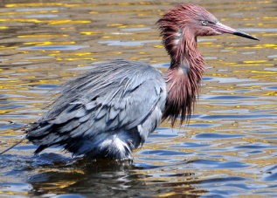**O: Bolsa Chica Ecological Reserve Newcomer Hike:** Easy paced, reasonably flat, 5 mile hike, approx 3 hrs. Newcomers Welcome. Enjoy the natural beauty of Bolsa Chica, one of the last remaining wetland ecosystems in Southern California. Meet 8:30 am. From Warner Avenue in Huntington Beach turn south on Bolsa Chica Street to the end of the street and trailhead (Brightwater). Park on the street. Bring camera, water, sun protection, hat, light hiking boots, rain does not cancel. Ldrs: Houria Hall, Donna Specht, Karen Belville, Julie Garner, Dorothy Gutierrez

**Like us on Facebook:** [**http://www.facebook.com/ocsierrasingles**](http://www.facebook.com/ocsierrasingles)

Sunday, August 21, 8:30 AM                  OCSS

**O: Bolsa Chica Ecological Reserve Newcomer Hike:** Easy paced, reasonably flat, 5 mile hike, approx 3 hrs. Newcomers Welcome. Enjoy the natural beauty of Bolsa Chica, one of the last remaining wetland ecosystems in Southern California. Meet 8:30 am. From Warner Avenue in Huntington Beach turn south on Bolsa Chica Street to the end of the street and trailhead (Brightwater). Park on the street. Bring camera, water, sun protection, hat, light hiking boots, rain does not cancel. Ldrs: Houria Hall, Dorothy Gutierrez, Barbara Creighton

**ADVANCE ACTIVITIES**

Wednesday, September 7, 9:00 AM      OCG, SAGE, OCSS

**Salt Creek Bagel hike:** 7.5 mi, 200' gain, moderate. Scenic walk from Chapparosa Park to the beach, then up over the Headlands to Dana Point Harbor. Return by bus after lunch (optional) at the Bagel Place. Meet 9:00 am at Chapparosa Park. From I-5 go W on Crown Valley, L on Golden Lantern, R on Chapparosa and through park to the very end. Those arriving by 8:45 may wish to take the first R after turning onto Chapparosa and parking there. Bring water, walking shoes, bus fare ($0.75 seniors, $2 others). Newcomers welcome. Ldrs: Helen Maurer, Linda Ledger

Wednesday, September 14, 9:00 AM     OCG, SAGE, OCSS

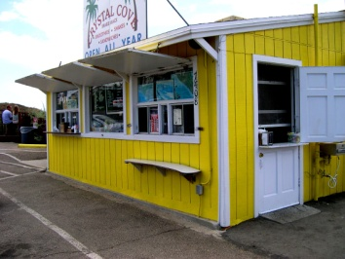**Crystal Cove Beach Walk:** 6 mi, 200' gain. An early summer stroll along the beach & bluff top in this beautiful State Park in Newport Beach. Optional stop at Ruby's Date Shack. Meet 9:00 am at the SW corner of PCH and Cameo Shores. Park on Cameo Shores or Cameo Highlands. Bring water, walking shoes. Ldr: Pete Height, Asst: Sylvia Stevenson, sjstevenson2828@yahoo.com

Wednesday, September 14, 6:00 PM    OCG

**Spaghetti Feed and Get Together:** Join us at 6 pm at Cook's Corners for a spaghetti/salad dinner and a good time get-together. Spaghetti plate with salad $4 per person. Bring friends & family! (From I-5, E on El Toro several miles, which changes to Santiago Cyn Rd, R on Live Oak Cyn Rd and Cook's Corners.) Contact Sherri Sisson for details. 949-786-7681 sksisson@gmail.com

Sunday, September 18, 8:30 AM   OCSS

**O: Bolsa Chica Ecological Reserve Newcomer Hike:** Easy paced, reasonably flat, 5 mile hike, approx 3 hrs. Newcomers Welcome. Enjoy the natural beauty of Bolsa Chica, one of the last remaining wetland ecosystems in Southern California. Meet 8:30 am. From Warner Avenue in Huntington Beach turn south on Bolsa Chica Street to the end of the street and trailhead (Brightwater). Park on the street. Bring camera, water, sun protection, hat, light hiking boots, rain does not cancel. Ldrs: Houria Hall, Julie Garner, Steve Bradford

**Saturday, September 24- October 1 OCSS**

**O: 203040's COLORADO ROCKY MOUNTAIN ADVENTURE, VAIL, CO:** Fall colors of the Colorado Rockies await your gaze on easy-moderate 3-6 mile hikes. Each evening, we'll cook healthy food at our Vantage Point Condominium, enjoy the hot tub, and watch movies. You must have hiked with one of the leaders before the event to assess skill level. We will be sharing a 2 bedroom unit, so plan to camp on floor. Bring your sleeping bag and sleeping pad. Couples or those willing to share get first dibs on the beds. Pre-pay $400 by check to OCSS, c/o Scott Closson, 19 Night Bloom, Irvine, CA 92602 for full amount. Refunds only if someone takes your spot. Meet at Denver International Airport (DIA) at 1pm. Limit: 8. David Kuhn 714-883-9893 [mtndave@cox.net](mailto:mtndave@cox.net), Scott Closson 714-457-6820 closs100@mail.chapman.edu.

**Wednesday, September 28, 7:15 AM     OCG, SAGE, OCSS**

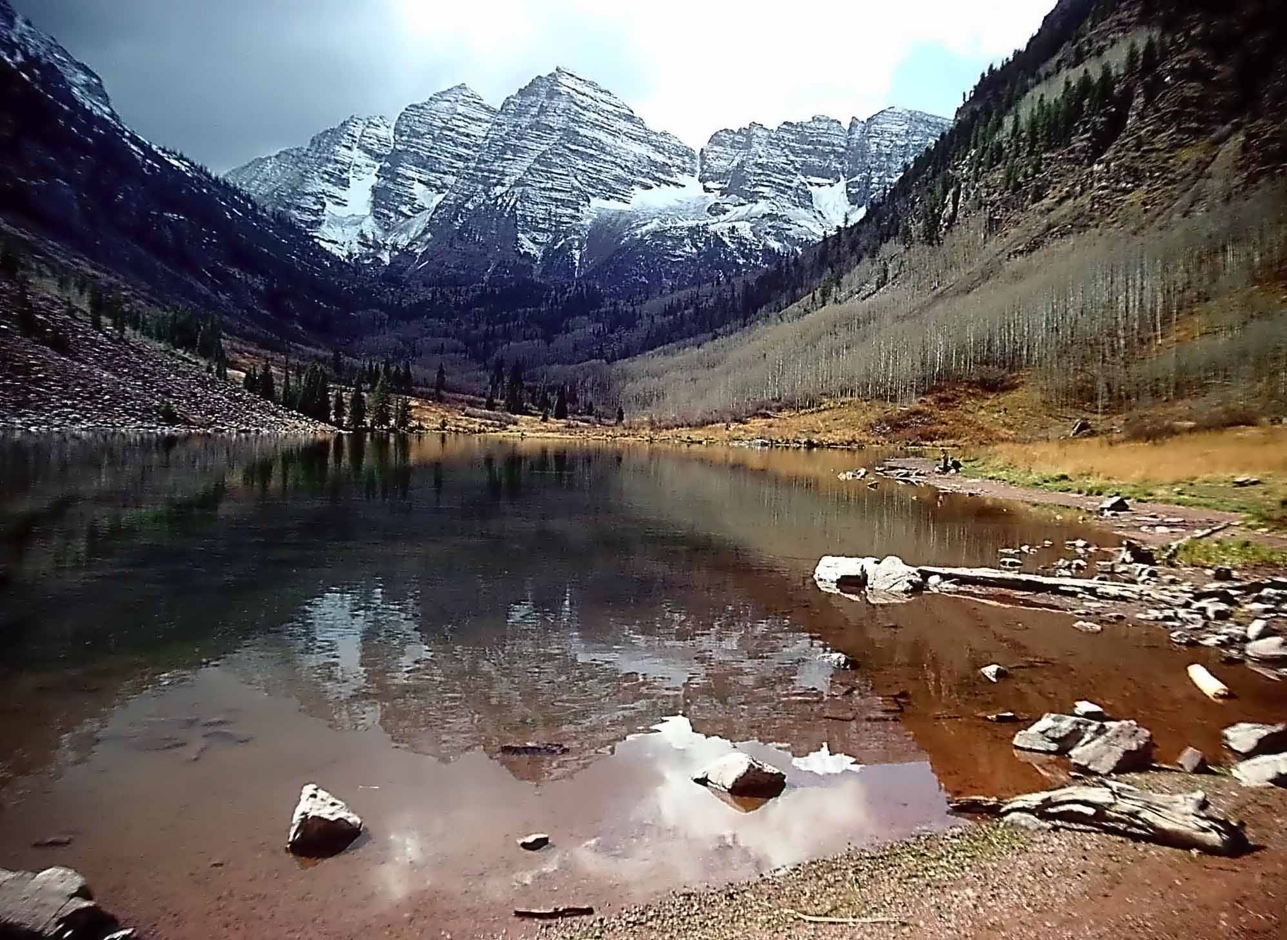

**Maroon Bells Aspen Photo by Dick Clement**

**Icehouse Canyon:** Join us for an 8 mi, 2600' gain hike in the San Gabriel Mtns along an inviting creek, past private cabins and through beautiful forests. We'll have a snack at Columbine Spring, lunch at the saddle and return the way we came. Meet 7:15 am at the Tustin Rideshare (one block south of I-5 on Redhill in the portion of the parking lot at the Stater Bros strip mall that extends behind the Union 76 gas station). Bring 2+ liters water, lunch/snacks, lugsoles, poles, rain jacket, non-cotton layers. Rain cancels. Ldrs: Rich Maxey, Linda Ledger, linda.ledger@cox.net

**For complete up-to-date listings of Orange County Sierrans Section events go to: http://angeles.sierraclub.org/ocss**

Saturday, October 1, 2016 7:30 AM  Leadership Training

**LEADERSHIP TRAINING SEMINAR: DARE TO LEAD!!** What better way to step up and lead your favorite outing than by taking advantage of the training opportunities that the Angeles Chapter provides each year. As home to one of the largest outings programs on the planet, the Sierra Club Angeles Chapter's many groups, sections and committees sponsor thousands of trips ranging from easy hikes to backpacks to world wide travel and mountaineering expeditions. Taught by experienced volunteer leaders, the seminar covers all the basics of leadership. You will learn how to plan a trip, prevent problems on the trail and make sure that everyone has a great time. You'll gain knowledge about good conservation and safety practices, along with tips for getting your “O” rating quickly. The all-day class costs $25. The application is available online at angeles.sierraclub.org/ltc_leadership_seminar. Mail the application and check $25, payable to Sierra Club, to Steve Botan, LTC Registrar, 18816 Thornwood Circle, Huntington Beach 92646. Steve by email (ltcregistrar@hundredpeaks.org) or by phone (714-321-1296). **Applications and checks are due Sept. 17, 2016** Scholarships are available for those with financial need. Apply to LTC Chair Anne Marie Richardson [AMLeadership@gmail.com](mailto:AMLeadership@gmail.com)

Saturday, October 1, 8:00 AM       SIERRA SAGE, OCSS

**O: Trail Maintenance in the San Mateo Canyon Wilderness**: The Santa Ana Mountain Task Force maintains trails in the San Mateo Canyon Wilderness. Volunteers, male and female, keep the trails open and safe. The location of each month's activity depends on the current trail conditions. To receive monthly email notices with details for that month, contact John. The work will involve cutting back or removing plants to provide a proper corridor and correcting drainage and erosion problems. Tools are provided. Bring work gloves, sturdy boots, water, lunch. Meeting location is usually at the south Orange County ride share at either 7:30 or 8:00 am depending on the location of the work. Rain or critical fire danger will cancel. Leader: John Kaiser (jkai39@gmail.com). Assistant: Rich Maxey

Wednesday, October 5, 9:00 AM OCG, OCSS

**O: Aliso/Wood Canyon:** Join us for a 8-10 mi, 600' gain loop from Canyon View Park to Top-of-the-World Park, then down into Aliso Wood Cyn Wilderness park and ending back at Canyon View Park. If time allows, we will take a lovely nature trail that is only used by hikers and back to our cars. Meet 9:00 am at Canyon View Park with hiking boots, water, snacks, hat & sunscreen. From El Toro Rd in Laguna Woods, turn S on Moulton about 1 mi, then R on Glenwood and up the hill, over the toll road, R on Canyon Vista Dr. Park at bottom of hill on street. Canyon View Park is on the Left. Rain, 3 days after rain, cancels. Ldr: Audrey Tomovich [ourmeandog@yahoo.com](mailto:ourmeandog@yahoo.com), Jan Nemmert

Wednesday, October 12, 8:30 AM                  OCG, SAGE, OCSS

**O: Whiting Ranch/Billy Goat Loop Hike:** Join us for a strenuous, moderately-paced 7 mi rt 1400' gain/loss hike up Serrano Canyon and Dreaded Hill to Four Corners and the Billy Goat Trail, returning through Sleepy Hollow with possible deer sighting. Bring 2 liters water, snacks, hiking boots, sun protection, $3 for parking or annual pass. Meet 8:30 am at the Glenn Ranch Rd entrance in Lake Forest. Exit I-5/405 at Bake Pkwy, go E 5 mi, R on Portola, L at Glenn Ranch Rd ½ mi and L into parking lot. Rain cancels. Ldr: Sharon Kirk Asst: Sylvia Stevenson

Wednesday, October 19, 8:30 AM         OCG, OCSS

**O: O'Neill Park:** 7 mi, 700' gain. Our route begins on the Live Oak Trail past the nursery and traversing a long ridge overlooking O'Neill Park proper. We hike along the main ridge before descending into one of the park's several oak-shaded canyons and the park HDQTs, then loop around the canyon bottom and return to the ridge via another canyon. Meet 8:30 am at the end of Meadow Ridge Dr. Take El Toro Rd E to the next light past Glenn Ranch Rd, turn R on Valley Vista Way, R on Meadow Ridge to the end. Rain within 3 days cancels. Bring 2 qts water, lunch/snack, hiking shoes/boots. Ldr: Rich Maxey, [richmaxey@yahoo.com](mailto:richmaxey@yahoo.com), Michael Sappingfield mikesapp@cox.net

Sunday, October 16, 8:30 AM       OCSS

**O: Bolsa Chica Ecological Reserve Newcomer Hike:** Easy paced, reasonably flat, 5 mile hike, approx 3 hrs. Newcomers Welcome. Enjoy the natural beauty of Bolsa Chica, one of the last remaining wetland ecosystems in Southern California. Meet 8:30 am. From Warner Avenue in Huntington Beach turn south on Bolsa Chica Street to the end of the street and trailhead (Brightwater). Park on the street. Bring camera, water, sun protection, hat, light hiking boots, rain does not cancel. Ldrs: Houria Hall, Dorothy Gutierrez, Karen Belville, Donna Specht

Monday, November 14, 6:30 PM   Angeles Chapter, OCSS

**Newcomer/Member Meet Greet Eat, Thanksgiving Night:** We invite you to an activity packed evening: Introduction of our new leaders, Free Drawing, find out all about our events with 20s/30s/40s, our award winning Weekly Conditioning Hikes, Social activities, conservation outings and Adventure Destinations and Winter Sports Program. Chance to purchase Sierra Club logo daypacks and other cool gifts. Newcomers welcome! Meet 6:30 pm, Costa Mesa Neighborhood Community Center, 1845 Park Avenue, Costa Mesa. $5 Donation. Optional, bring a Thanksgiving side dish, potluck item and we will provide the turkey, fixins and drinks. Join Sierra Club @ special introductory offer $15 and receive a free gift! Bring A Friend! Contact: Donna Specht (donnaspecht@juno.com)

Sunday, November 20, 8:30 AM    OCSS

**O: Bolsa Chica Ecological Reserve Newcomer Hike**: Easy paced, reasonably flat, 5 mile hike, approx 3 hrs. Newcomers Welcome. Enjoy the natural beauty of Bolsa Chica, one of the last remaining wetland ecosystems in Southern California. Meet 8:30 am. From Warner Avenue in Huntington Beach turn south on Bolsa Chica Street to the end of the street and trailhead (Brightwater). Park on the street. Bring camera, water, sun protection, hat, light hiking boots, rain does not cancel. Ldrs: Houria Hall, Dorothy Gutierrez,Donna Specht, Steve Bradford

Sunday, December 18, 8:30 AM   OCSS

**O: Bolsa Chica Ecological Reserve Newcomer Hike**: Easy paced, reasonably flat, 5 mile hike, approx 3 hrs. Newcomers Welcome. Enjoy the natural beauty of Bolsa Chica, one of the last remaining wetland ecosystems in Southern California. Meet 8:30 am. From Warner Avenue in Huntington Beach turn south on Bolsa Chica Street to the end of the street and trailhead (Brightwater). Park on the street. Bring camera, water, sun protection, hat, light hiking boots, rain does not cancel. Ldrs: Houria Hall, Dorothy Gutierrez,Donna Specht, Julie Garner, Karen Belville

A Note on Phone Etiquette…

When Calling a Team member, leader or host, please call between 9 AM and 9 PM only, **unless the write-up states otherwise.** Remember E-mail, the silent call! Very Much appreciated by all! Thanks to our active OCSS leaders and hosts

|  |  |  |
| --- | --- | --- |
| Abele, Kathy  Abele, Kathy | O | 949-951-0280 |
| Bartlett, Bart | O | 714-968-5099 |
| Bartlett, Shilo | O | 714-968-5099 |
| Botan, Steve | O | 714-321-1296 |
| Bradford, Stephen | O | 310-993-5501 |
| Cadez, Ana | OW | 626-836-2235 |
| Campbell, Ron | M | 714-962-8521 |
| Clark, Todd | I | 714-803-0195 |
| Clement, Dick |  | richsea@sbcglobal.net |
| Closson, Scott | O | 714-457-6820 |
| Côté, Sylvie | I | 949 547-2998 |
| Creighton, Barbara | O | 714-960-3949 |
| Dodson, Michael | MW | 714-529-6020 |
| Dodson, Phyllis | OW | 714-529-2440 |
| Domont-Bohl, Ghia | O | 949-719-2914 |
| Fleming, Mark | IW | 626-712-3671 |
| Forry, Harry | OW | 714-962-4136 |
| Franciosi, Laura | O | 714-879-1760 |
| Frankiewicz, Ron | O | 949-631-8071 |
| Garner, Julie | O | 714-335-1579 |
| Geller, Charles | O | 714-292-2352 |
| Graham, Sandy | OW | 714-282-5661 |
| Graham, Scott | O | 714-282-5661 |
| Hall, Houria | O | 714-767-5327 |
| Hills, Margie | O | 714-256-0807 |
| Huang, James | O | 949-287-4455 |
| Johnson, Jerry | O | 626-484-2983 |
| Juarez, Ana | O | 714-323-3627 |
| Kenyon, Joel | O | 949-285-5909 |
| Khoshab, Karim | O | 949-559-1388 |

**Please Join us on our MEDIA sites!!**

**http://www.meetup.com/Orange-County-Sierra-Singles/**

**http://www.meetup.com/Orange-County-Sierra-Singles-20s-30s-40s/**

**Sierra Club Angeles Chapter: http://angeles.sierraclub.org**

**Like us on Facebook: http://www.facebook.com/ocsierrasingles**

**For a complete list of Angeles Chapter Travel Adventures go to:**

**http://angeles.sierraclub.org/get_outdoors/travel_adventure**

**Follow Angeles Chapter Travel Adventures on Facebook**

[**https://www.facebook.com/SierraClubAngelesTravel**](https://www.facebook.com/SierraClubAngelesTravel)

|  |  |  |
| --- | --- | --- |
| Kirk, Sharon | O | 714-376-3197 |
| Kuhn, Dave | I | mtndave@cox.net |
| Lamb, Fred | O | 949-350-6451 |
| Lai, Frank | O | 949-262-1448 |
| LaRue, John | O | 949-854-7919 |
| Lazzelle, Fred | H | 714-870-4469 |
| Le, Kenadi | O | 818-445-2333 |
| Lejins, Diana | O | 562-421-8012 |
| Lyons, Gaines | O | 562-491-2022 |
| Martin, Keith | MW | 310-530-1268 |
| Maynard, Joe | O | 562-981-9111 |
| Meek, Scott | IW | 909-393-0630 |
| Mitchell, Mark | IW | 818-753-9328 |
| Montgomery, Norm | O | 714-557-0794 |
| Nemmert, Jan | OW | 714-962-4136 |
| Opperman, Sanford | H | 714 993-0651 |
| Palmer, Jim | O | 949-551-8912 |
| Penn, Fran | I | 714-747-1019 |
| Puraty, Sharry | O | 714-761-8761 |
| Sharp, Gwen | IW | 714-672-9525 |
| Smith-Meek, Julie | IWC | 909-393-0630 |
| Specht, Donna | IWC | 714-963-6345 |
| Talbott, Virgil | EW | 714-871-7900 |
| Thio, Kwee | O | 714-841-7988 |
| Van Strien, Maura | O | 714-962-3166 |
| Weinreich, Phil | O | 949-733- 2730 |

|  |  |
| --- | --- |
| Orange Peal Deadlines | |
| Write ups Due | ISSUE |
| Feb 1 | Mar/Apr |
| Apr 1 | May/June |
| June 1 | July/Aug |
| Aug 1 | Sept/Oct |
| Oct 1 | Nov/Dec |
| Dec 1 | Jan/Feb |

|  |  |  |
| --- | --- | --- |
| **OCSS Management Committee** | | |
| Chair | Houria Hall | houriazhall@yahoo.com |
| Vice Chair/Secy | Charles Geller | EduRight@aol.com |
| Outings/Treasurer/Membership | Donna Specht | donnaspecht@juno.com |
| 20's/30's/40s | Scott Closson | sclosson0@icloud.com |
| At Large | Ana Juarez | ajcoyame@aol.com |
| Database Assist. | Annie Simjee | annebotz6@gmail.com |
| **Standing Committees** | | |
| Bookkeeper | Ron Frankiewicz | Upon request |
| Mailout | Barbara Creighton | bcreighton@socal.rr.com |
| Backpacking | Fran Penn |  |
| Nominations | Kathy Abele | KatHiker@cox.net |
|  | John La Rue | jclarue@cox.net" |
| Elections | Virgil Talbott | virgil_talbott@roadrunner.com |
|  | Howard Huang | hh99usa@yahoo.com |
| Safety | Ron Campbell | campbellr@verizon.net |
| Newsletter Editor | Dick & Paula Clement | richsea@sbcglobal.net |

**ORANGE PEAL SUBSCRIPTION INFORMATION**

**New Subscriptions/Address Changes:** Please complete the form below and mail. Inquiries or Problems: Please address inquiries in writing to OCSS, ℅ Joel Kenyon, 27492 Los Banos, Mission Viejo, CA 92691. Contact the Membership Chair if you have any questions.

|  |
| --- |
| ***OCSS* Orange County Sierrans Section**  **℅ Joel Kenyon, 27492 Los Banos, Mission Viejo, CA 92691**  ***Orange Peal Subscription Form*** |
| Name: _____________________________________________________________ |
| Address: ___________________________________________________________ |
| City:_________________________________ State: ______Zip_______________ |
| Phone No: (_____)______________________________ |
| E mail: ___________________________________________________________  Sierra Club #:____________________Expiration Date: _____________________ |
| **Subscription Categories**  SC Member one year* $12 SC Member two years* **$22**  SC Member three years* **$30** NonMember **$17** |
| New **Check#**: _______ |
| Renewal  Change of Address  Thank you for your Membership! Remember to Renew your Sierra Club Membership. |
| *All $12 memberships must include Sierra Club Number |

**Why join the Sierra Club?**

**Because we need you!**

**Your voice will be added to those of more than 600,000 of your fellow Americans who are committed to leave our children a living legacy — clean air, clean water, and natural grandeur.** The Sierra Club has been instrumental in preserving wilderness, wildlife and nature's most splendid wild places for over 100 years — Yosemite National Park, Grand Canyon National Park, the Florida Everglades and the Sequoia National Monument to name just a few — helping protect over 150 million acres of wilderness and wildlife habitat.

**The Sierra Club is America's most effective advocate for the environment and helps you protect the environment locally and globally.** From community issues and action to lobbying on a national level, membership helps you take action where it's needed most. As a member you'll have opportunities to get involved with local chapters, as well as be part of the largest national network of environmental advocates. You'll have the satisfaction of helping preserve irreplaceable wild lands and wildlife. **Your membership counts!**

**So please — Join the Sierra Club today!**

**And remember to Renew!**

**Or go online to join:**

**http://angeles.sierraclub.org/ocss**